Nexus - High Level Design Doc (Revision 4)

1. Glossary

Topic | Description
Persona | Role based access control in Nexus
Industry Framework | A scaffold of guidelines, standards, and best practices. Example NIST-800-53-r3, CIS, etc
Control | A safeguard or countermeasure prescribed for an information system or an organization designed to: 1. Protect the confidentiality, integrity, and availability of information. 2. Meet a set of defined security and privacy requirements.
Component | Components are the individual elements or building blocks that can be used to implement or satisfy a control.
CDK | AWS Cloud Development Kit
SA | Security Assurance QA
OSCAL | Open Security Controls Assessment Language
WAF | Web Application Firewall
DDB | Dynamo Database (DB)
TTL | Time to live. A time period after which rows in DDB are deleted automatically.
Catalog Control | AWS Service Controls in Security Hub https://docs.aws.amazon.com/securityhub/latest/userguide/securityhub-controls-reference.html
SME | Subject Matter Expert/Domain expert
RBAC | Role based access control
BYOC | Bring Your Own Control
ACID | Atomicity, Consistency, Isolation, and Durability (in reference to database atomicity)
BRASS | Bindles Resource Authorization Support System
SIM | Ticket system

2. Background
A customer would like AWS controls to be mapped to industry standard controls so that they can implement right AWS controls to maintain their organizational compliance posture. Mapping an AWS control to industry standard controls is a manual, labor-intensive process that requires two full-time SMEs about 1.5 - 2 months of time to interpret and correlate a single compliance framework to about 1,500 AWS service resource controls. At present, AWS audit manager covers about 17 compliance frameworks and AWS security hub controls cover about 85 of 1,500+ AWS resource types (~7%), mapped to 3 compliance standards namely NIST, CIS, PCI-DSS. At present, it takes 12.5 minutes for a SME to map one AWS service control to controls in a framework and an additional 8 mins for QA to verify the mapping. Research shows organizations spend 4,300 hours annually on compliance activities, with engineering teams contributing 100-300 hours per SOC 2 audit alone [16]. Subject matter experts must carefully review each control statement, understand its security implications, and manually identify corresponding controls across multiple industry frameworks.

Mapping 1,500 AWS controls to a standard at an average of 20.5 minutes each requires approximately 30,750 minutes (20.5 x 1,500), representing significant financial costs. This manual approach creates several critical challenges: inconsistent interpretations between different reviewers, reviewer’s personal bias, difficulty in scaling as new services and frameworks are introduced, etc. The process can be error-prone and require constant maintenance as frameworks evolve. This creates a substantial operational burden on security teams who could otherwise focus on more strategic initiatives.

Following is an example of EC2 control to industry standards. More examples can be found in AWS Security Hub.
[EC2.1] Amazon EBS snapshots should not be publicly restorable
Related requirements: PCI DSS v3.2.1/1.2.1,PCI DSS v3.2.1/1.3.1,PCI DSS v3.2.1/1.3.4,
PCI DSS v3.2.1/7.2.1, NIST.800-53.r5 AC-21, NIST.800-53.r5 AC-3,
NIST.800-53.r5 AC-3(7), NIST.800-53.r5 AC-4, NIST.800-53.r5 AC-4(21),
NIST.800-53.r5 AC-6, NIST.800-53.r5 SC-7, NIST.800-53.r5 SC-7(11),
NIST.800-53.r5 SC-7(16), NIST.800-53.r5 SC-7(20), NIST.800-53.r5 SC-7(21),
NIST.800-53.r5 SC-7(3), NIST.800-53.r5 SC-7(4), NIST.800-53.r5 SC-7(9)
Category: Protect > Secure network configuration
Severity: Critical
Resource type: AWS::::Account
AWS Config rule: ebs-snapshot-public-restorable-check
Schedule type: Periodic
Parameters: None
This control checks whether Amazon Elastic Block Store snapshots are not public. The control fails if Amazon EBS snapshots are restorable by anyone.
EBS snapshots are used to back up the data on your EBS volumes to Amazon S3 at a specific point in time. You can use the snapshots to restore previous states of EBS volumes. It is rarely acceptable to share a snapshot with the public. Typically the decision to share a snapshot publicly was made in error or without a complete understanding of the implications. This check helps ensure that all such sharing was fully planned and intentional.
Remediation
To make a public EBS snapshot private, see Share a snapshot in the Amazon EC2 User Guide. For Actions, Modify permissions, choose Private.

Who are our customers?
- SAS Consultants, and Security Assurance QA will use Nexus via Web interface. They will view controls, view and review mappings, and provide feedback on mappings.
- Service Teams such as Control Catalog will access Nexus via API calls.
- In future (out of scope for this HLD), AWS customers will access Nexus through Numa.

3. Purpose
The goal is to develop an AI/ML- driven solution to automate the mapping process and achieve SME grade accuracy, significantly reduce manual effort, and time. The system aims to maintain high accuracy and reduce mapping time from 1.5 - 2 months to Tk hours. This will result in mapping all AWS control to all supported industry controls and customers can rely on AWS control mappings for their compliance needs.

This high-level design document outlines the architectural blueprint to implement Nexus, an AI-driven regulatory compliance mapping system. The solution aims to automate the complex process of mapping security control statements to multiple industry frameworks while maintaining human oversight through a robust validation workflow. This innovative system will significantly reduce the manual effort currently required in compliance mapping while ensuring high accuracy and audibility.

The architecture follows a micro-services approach that divides essential functions into two separate workflows. The first operates behind the scenes, like handling control ingestion, control mapping, and QA-driven mapping verification. The second workflow provides the user-facing interface where customers can examine mappings across controls from various frameworks. These modules communicate via clearly defined APIs and adhere to industry-standard engineering practices while enforcing rigorous security and access management protocols.

The solution emphasizes scalability, maintainability, and extensibility through its modular design. Initially focused on mapping AWS Service control statements to 17 industry frameworks (by end of this year), the architecture is built to accommodate future expansions. The system incorporates comprehensive logging and audit trails, ensuring transparency and traceability of all mapping decisions, while supporting integration with existing AWS services such as Control Tower, Config Rules and Security Hub

4. Requirements
Nexus has been designed based on following set of requirements. These are P0 requirements gathered from Nexus User Stories. This HLD document is not the source of truth for requirements. Requirements listed here are just to provide context and define scope. Find requirements here : Requirements: Nexus User Stories

4.1. Functional Requirements

 | Classification | Requirement
1 | New AWS Control | Control Catalog/Control Guide/Control Objective/Common Control calls Nexus API and provide new AWS controls to map
2 |  | An existing AWS control when updated, will be treated as a new control and mapped again to all industry controls.
3 |  | When an existing AWS control is updated, Nexus versions the control internally and retains mapping of previous definitions for audit trailing purposes.
4 | Create mapping | Once a new AWS control is ingested, Nexus compares the control against all of the supported industry or BYOC controls and identifies mappings.
5 |  | A QA can submit a mapping between two existing controls. This mapping will go through the same 2 QA process identical to control mappings identified through science workflows.
6 | QA workflow | Nexus opens a SIM with QA team once a new mapping is available to review.
7 |  | QA1 reviewes mappings and provide approval/denial decision with feedback.
8 |  | Nexus updates the SIM to indicate that QA1 has provided their decision and QA2 review is now pending.
9 |  | Once QA1 decision is recived, QA2 will be presented with an additional checkbox "final approval".
10 |  | A mapping is considered approved if both QA1 and QA2 approve the mapping.
11 |  | A mapping is considered rejected if both QA1 and QA2 reject the mapping.
12 |  | If QA1 and QA2 are in disagreement, QA2 will use various mechanisms to reach a final agreement and submit it through Nexus UI.
13 |  | QA2 can submit many intermediate decisions and they all will be captured, but the decision with "final approval" checked will be considered the final decision.
14 |  | All QAs are able to view feedback associated with a mapping.
15 |  | Once a new mapping is approved, Nexus notifies downstream like Control Catalog.
16 | View mappings | Provide web interface for users to interact with Nexus.
17 |  | Supports RBAC based access control to allow actions on the UI based on role of the user.
18 |  | Users can view/select/filter specific AWS services (S3, EC2, etc) mappings for in scope industry frameworks.
19 |  | Given a control, Nexus returns a list of all controls it maps to.
20 |  | Provide rich set of APIs for programatic access to mappings in Nexus.
21 | Mapping management | SAS consultants can provide thumbs up/down feedback with reason on an existing mapping.
22 |  | A thumbs down feedback from SAS consultant results into a ticket for QA team to review the mapping decision.
23 |  | Nexus Admins can archive a mapping through a ticketing mechanism
24 |  | Invalidated mapping will continue to remain in the system and will be used for audit trailing, model fine-tuning, etc.
25 | New industry framework | This topic is out of scope. The documet is based on the assumption that science models used by Nexus are capable of mapping to standards controls. Supporting a new framework control may require finetuning the model before it can be ready to be used.
26 |  | A new version of an existing standard will be treated as an independent standard and each control will be mapped to relevant existing AWS controls.

4.2. Non-Functional/Operational Requirements

 | Classification | Requirements
1 | Service Management | System monitoring and alerting
2 |  | Backup and recovery procedures
3 |  | Basic error handling and logging
4 |  | Support A/B testing for each component, especially the ones using AI agents
5 |  | Version control management
6 | Security Controls | Role-based access control
7 |  | Authentication and authorization
8 |  | Data protection measures
9 |  | Secure API access
10 |  | Audit logging
11 | Testability | Allow unit tested code to deploy to Gamma/Prod
12 |  | Integration tests for each component and end-to-end. Integration tests to run in each stage post deployment.
13 |  | Canary tests to run in Prod stages
14 |  | Support load testing capabilities.
15 | SLAs | Control mapping recall will be greater than TK%
16 |  | Control mapping precision will be greater than TK%
17 |  | Nexus APIs wil have 99.99% availability in all regions
18 |  | Nexus APIs will have end-to-end latency < 200 ms in all regions.

4.3. Role Requirements
Nexus implements strict security boundaries with role-based access control for different personas such as Security Assurance QA, SAS Consultant, Service (like Control Catalog), and Admin. Roles help define a boundary on what a user can do when using Nexus. All roles and capabilities are listed in Nexus User Stories document. Nexus implements Role-Based Access Control (RBAC) to achieve this fine-grained access control. Following is a summary of operations that each role can perform.
 | Operation | Role(s)
1 | Provide new/update AWS controls | Service
2 | Archive controls | Admin
3 | Identify mapping between a new control with other existing controls. | Admin
4 | Create mappings manually | QA | Admin
5 | View unapproved mappings | QA | Admin
6 | Approve/deny newly identified mappings between controls | QA
7 | View approved mappings | QA | Consultant | Admin | Service
8 | View audit trail associated with a mapping | QA | Admin
9 | Provide feedback on an approved mapping | Consultant
10 | View feeback on an approved mapping | Consultant | QA | Admin
11 | Archive mappings | Admin

5. Scope

5.1. In Scope
All requirements listed above are in scope.

5.2. Out of Scope
- The architecture does not get into details related to science workflows, methods, their workings etc. Nexus uses science components as building blocks and assume they will work as expected. A science HLD will follow post-experimentation and that HLD will go in depth of all involved science components.
- Workflow related to adding support for a new industry framework is out of scope for this document. When a new industry framework is available, science models may need to be retrained and this is a process internal to Admins. A follow up HLD will be used to cover framework ingestion workflows.
- User interface will continue to evolve outside the scope of this document. UI will call APIs to interact with the application and use Midway to limit access to Amazon employees. Screenshots shared in this doc are visual aids to help visualize the data access patterns.
- QA process to review mappings is out of scope of this document. This process is captured in great detail QA Requirements for Nexus Mapping (P0).
- All P1 requirements are out of scope for this doc. The proposed design should be extensible to support P1 requirements through incremental changes, any opportunities to make current design more extensible is in scope.
- All Numa requirements are out of scope for this document, but the design should allow extending Nexus to support Numa.

6. Risks, Assumptions, Issues

6.1. Risks
- Change in UI components may result in data model changes and API changes. Depending on what stage of the project these changes are introduced, it may increase the scope and require additional time.
- Changes in science workflows may require changing the architecture.
- New findings and feedbacks received during AppSec review can impact the scope.
- Human-in-the-loop may have bias in evaluating AI/ML identified controls and mappings. Once user feedback signals are used to fine tune science workflows, biased feedback can influence model behaviors.
- AI workflow may fail to identify a valid mapping and the human-in-the-loop review may also miss to identify the missing mapping. As a result, we may have missing mappings in Nexus.

6.2. Assumptions
- Mapping mechanism developed by science team will be invokable as an API.
- Mapping mechanism is responsible for its adaptability to new controls and evaluation.

7. User Interface
User interface will continue to evolve outside the scope of this document. Following few screenshots here are to help with understanding the data access patterns. Current state of user interface can be experienced here https://beta.control-navigator.gss.aws.dev/review.

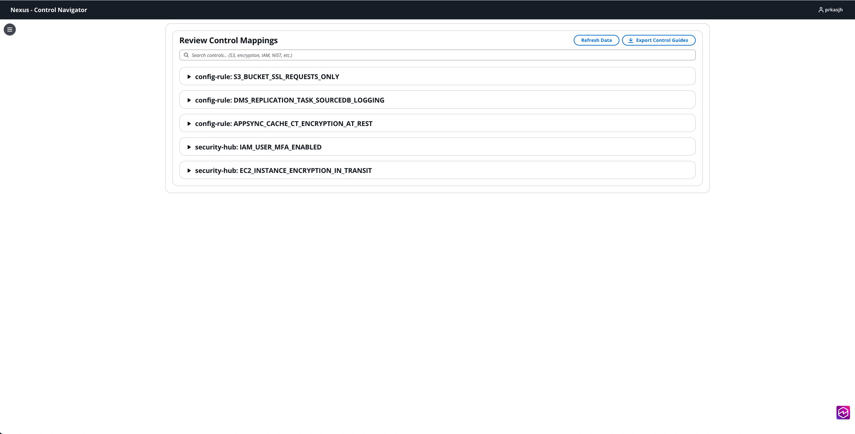
Figure 1: List of AWS controls with mappings requiring QA review.

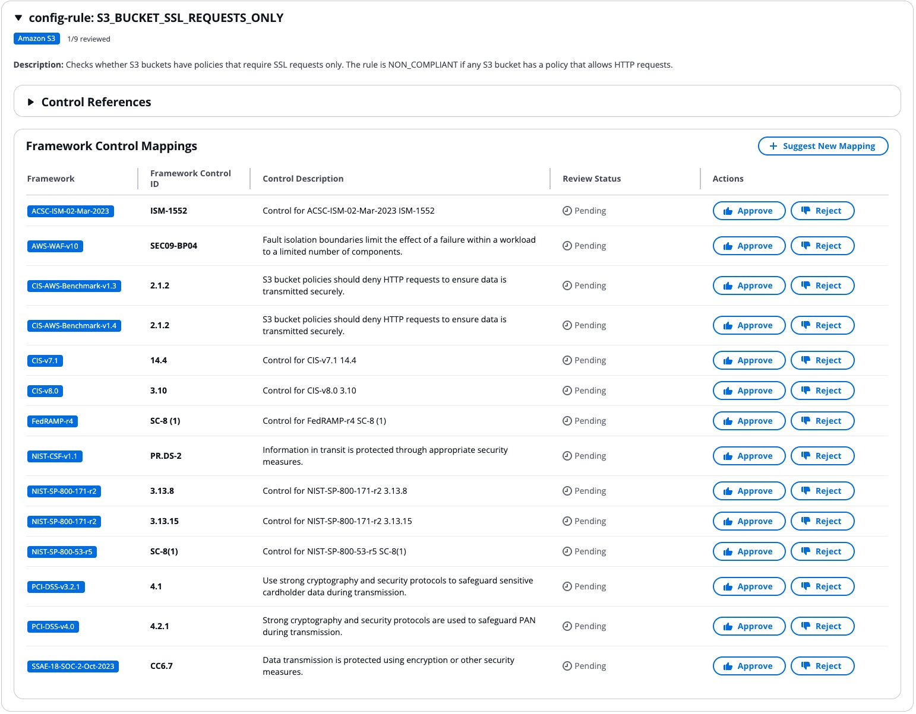

Figure 2: One of the AWS controls with list of available mappings to review.

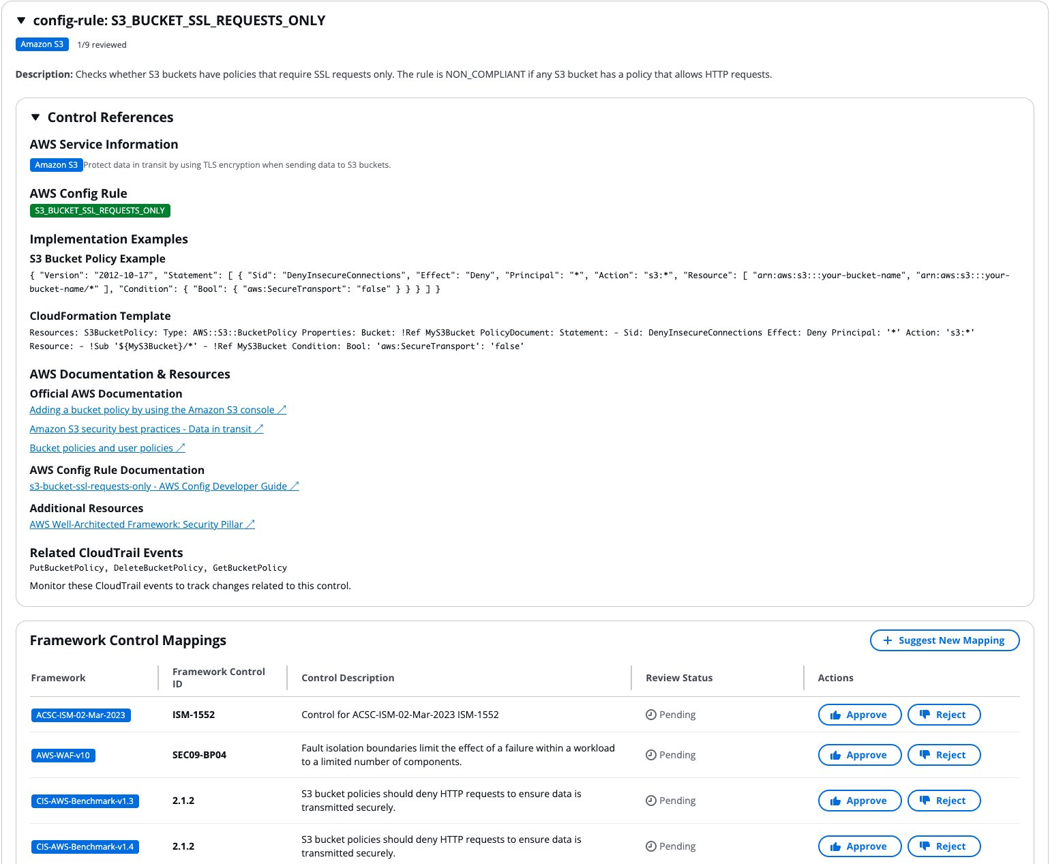
Figure 3: Details associated with AWS control to help build the context.

8. System Architecture
The system has been designed to the AWS Well Architected framework recommendations. At a high level, Nexus will ingest AWS controls, map it to supported BYOC and industry (NIST 800-53, PCI DSS, etc.) controls. Nexus provides APIs that users can use to obtain mappings between controls.

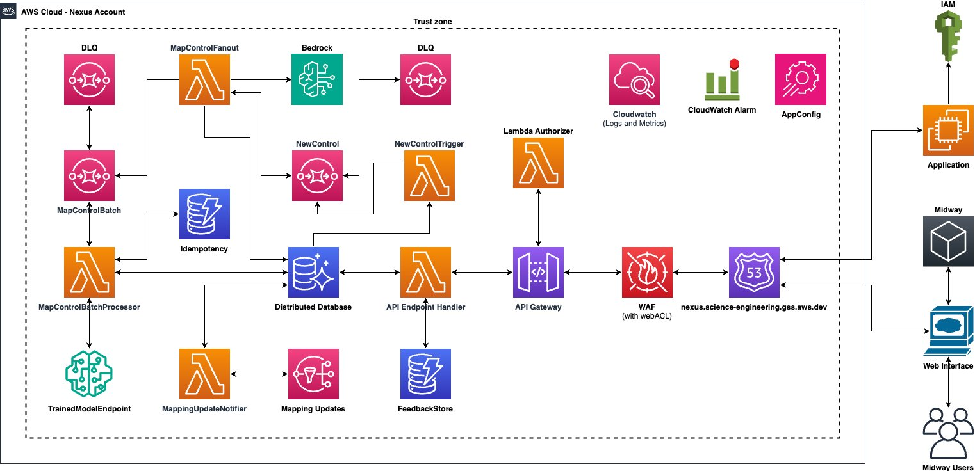
source
Figure: High level system architecture

9. High Level Design

9.1. Create Framework
A framework, identified by name and version, contains multiple controls. To ensure control consistence, we will require the control source (often a framework) to be created within the system, before accepting controls from it to map.

Our organization maintains centralized control over which industry frameworks Nexus supports. Framework creation APIs are not publicly exposed, ensuring governance and quality standards. Adding new industry frameworks requires submitting a ticket or SIM through established request channels. Upon approval, users with the Admin persona can create the requested framework in Nexus.

Framework names for AWS controls will be concatenation of AWS, Service-name , and Resource. The version will be set to 1.0. As an example, all EC2 controls related to EIP will have framework name as AWS::EC2::EIP and version as 1.0.
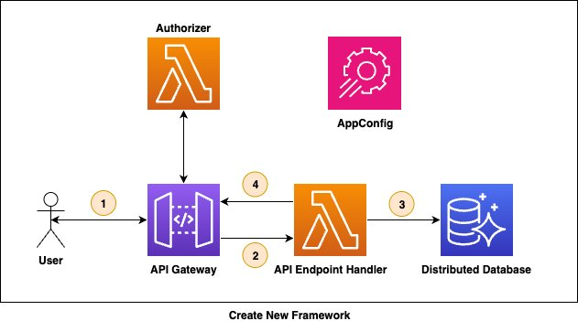

source
- /frameworks API is called to create a new framework.
- API Endpoint Handler validates the request.
- Framework is stored in the Framework table.
- API Endpoint Handler returns success to the caller.

APIs

View Framework

HTTP Method | API Endpoint | Description
GET | /api/v1/frameworks | List all frameworks associated with the caller's account.
GET | /api/v1/frameworks/{frameworkName} | List all versions of a given framework.
GET | /api/v1/frameworks/{frameworkName}/{frameworkVersion} | Lists details related to a specific framework version.

Create/Update Framework

HTTP Method | API Endpoint | Description
PUT | /api/v1/frameworks/{frameworkName}/{frameworkVersion} | Create or update a framework. If framework name and version needs to be updated, user must first archive it and then recreate it.

9.2. Archive Framework
Archiving a framework is potentially risky operation as it cascades to all associated controls, mappings, and QA/user feedbacks. Once created, framework name and version are immutable and cannot be modified. If corrections are needed due to typos or errors, old framework can be archived and a new one can be created. When a framework status is marked as ARCHIVED, the framework, none of it controls, and none of the control mappings are returned in response to API calls.

To minimize the risk of archiving Industry and AWS frameworks, the API is not exposed publicly. A ticket/SIM with Admin team is needed to archive industry frameworks. In response to the ticket, the Admin persona can take action on it.

APIs

Archive Framework

HTTP Method | API Endpoint | Description
POST | /api/v1/frameworks/{frameworkName}/{frameworkVersion}/archive | Archive specific version of the framework

9.3. Create Control
Nexus provides APIs to create new controls. When a new control is available in Nexus, Nexus saves it in its database, triggers a sync operation to find framework controls that the new control can map to and engage QA to review new mapping.
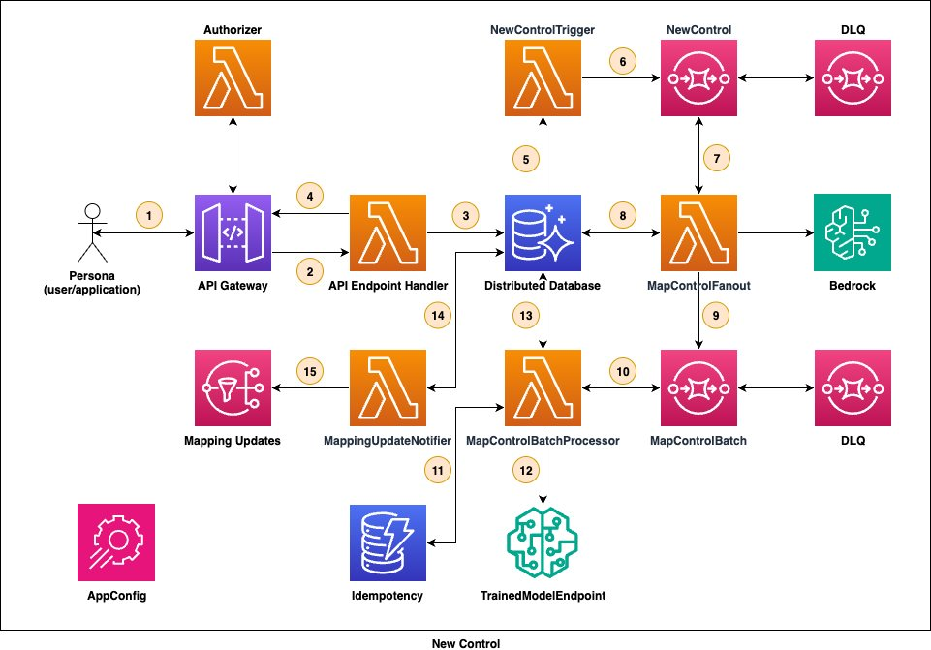
source

- Service/Admin persona calls createControl API to create a new control in Nexus. createControl API is a batch API and the caller can add up to 100 new controls per call.
- API Endpoint handler validates the request.
- API Endpoint handler then inserts the new control into the ControlDatabase.
- The API Endpoint handler then returns a 202 response to the user. Returning a 202 response gives us flexibility to change the backend workflow to async without impacting customer experience.
- An INSERT operation in the database will trigger NewControlTrigger lambda to start the mapping workflow.
- NewControlTrigger lambda is a lightweight lambda and it simply puts the new control into the New Control SQS queue. This operation takes < 250 ms. As a result, one lambda can handle up to 4 TPS. Max limit on concurrent lambda execution is 1,000 and can scale up to 4,000 TPS (4 x 1,000). This is way more than the current needs and has a lot of headroom to scale.
- Message in NewControlTrigger SQS queue triggers the MapControlFanout lambda to start the processes of mapping new control to existing framework controls.
- MapControlFanout enriches the control and stores the enrichment data into ControlEnrichment database.
- MapControlFanout then queries the ControlDatabase to get a list of all controls in all supported frameworks. The lambda creates a batch message with 100 (configurable) pairs and puts the message in the MapControlBatch SQS queue for further processing.
- MapControlBatchProcessor lambda picks up these batch messages from the MapControlBatch SQS queue and starts processing them. Multiple lambda instances can simultaneously process these batch messages.
- Before starting to process a batch message, the lambda first inserts the pair in the Idempotency database with a short TTL (TTL can’t exceed 15 mins). In case the lambda terminates before finishing a batch message, this idempotency check ensures that the next lambda that picks up this message does not process already visited pairs again. (This is a good to have and optimization step and can be skipped in P0 or unless retrying previously visited pair becomes a problem).
- For each control pair, the lambda calls the fine-tuned custom model and provides a control pair as parameter.
- If the model returns a positive response, the lambda INSERTS the mapping into the database with mapping status as REVIEW_PENDING.
- INSERT operation in the mappings table will trigger MappingUpdateNotifier lambda. The lambda will create a SIM to QA team CTI and start the QA process on the newly discovered mapping.
- Optionally, the MappingUpdateNotifier can also send a message to a SNS topic to notify Slack channels about new mappings.

API(s)

Create Control

HTTP Method | API Endpoint | Description
POST | /api/v1/frameworks/{frameworkName}/{frameworkVersion}/batchControls | Bulk API to create a max of 100 new AWS service controls per request. For AWS controls, `framework_name` can be `AWS::S3::Bucket` and `framework_version` can be `1.0`.
PUT | /api/v1/frameworks/{frameworkName}/{frameworkVersion}/controls/{controlId} | Create a new control with controlId.

List Controls

HTTP Method | API Endpoint | Description
GET | /api/v1/frameworks/{frameworkName}/{frameworkVersion}/controls | List all controls in a framework in a paginated manner.
GET | /api/v1/frameworks/{frameworkName}/{frameworkVersion}/controls/{controlId} | Get a specifc control

9.4. Update Control
Controls in industry frameworks don’t update. When an industry standard control changes, it triggers a new framework version release (minor version updates). Each framework version is treated as an independent entity where all controls must be mapped individually. For other framework types such as BYOC frameworks and AWS controls, updates are possible though infrequent. BYOC controls have the highest likelihood of modification, but BYOC framework management is out of scope for Nexus.

Rather than modifying existing records, control updates are persisted internally as new control versions with incremental version numbers. The updated control follows the same processing workflow as newly created controls. During mapping retrieval, the system returns only mappings associated with the latest control version, automatically filtering out mappings tied to previous versions.

APIs

Update Control

HTTP Method | API Endpoint | Description
PUT | /api/v1/frameworks/{frameworkName}/{frameworkVersion}/controls/{controlId} | Update an existing control.

9.5. Archive Control
Archiving a control is not a very common operation. A control may need to be archived when AWS service deprecates or some features deprecate, or better control replaces outdated ones, or customer wants to archive BYOC control, etc. When a control is archived, status of control is marked as ARCHIVED. When a control status is ARCHIVED, the control and none of its mappings are not returned in response to any API calls. If database becomes bulky because of too many ARCHIVED items, an offline batch process can delete ARCHIVED items and cleanup the database.

APIs

Archive Control

HTTP Method | API Endpoint | Description
PUT | /api/v1/frameworks/{frameworkName}/{frameworkVersion}/controls/{controlId}/archive | Archive specific control
POST | /api/v1/frameworks/{frameworkName}/{frameworkVersion}/controls/batchArchive | Bulk API to archive up to 100 controls per request.

9.6. Create Mapping
Nexus uses science workflows to identify mapping between controls in an async manner. Occasionally the science workflow may fail to identify few mappings. To mitigate this issue, Nexus supports manual/programatic addition of mappings. QA and Admin personas can add new mapping in the system. Once a mapping is manually/programmatically added, the state of new mapping is set to REVIEW_PENDING and this mapping goes through the same QA review workflow like mappings that are identified using science models.

APIs

Create Mapping

HTTP Method | API Endpoint | Description
POST | /api/v1/batchMappings | Bulk API to allow create up to 100 mappings per request.

9.7. Approve Mapping
Once a mapping between two controls are identified, the mapping has to go through a QA review process before it can be considered as a valid mapping. QA review is a multi-step multi-turn process that involves two or more (can be N) independent expert human reviewers to review the mapping and confirming if a mapping is valid.
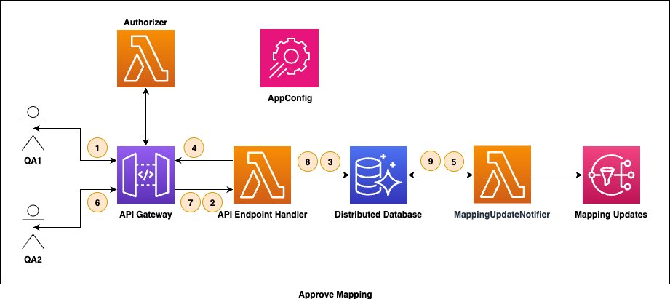
source

When a new mapping is identified, it is in REVIEW_PENDING state. MappingUpdateNotifier creates a SIM to QA CTI informing the QA team about new mapping available to review. Nexus saves the SIM identifier in the database and later use it to post updates on the SIM. QA team assigns a QA expert to review the mapping. This QA expert is named as QA1 in the diagram above.
- QA1 uses Nexus UI to list and review the available mapping. They submit their approval/denial decision along with reason in no more than 300 words and hit submit button. The response is captured by UI and it calls an API to submit the decision.
- API Endpoint Handler validates the submission and checks if more feedbacks are allowed for the mapping under review.
- API Endpoint Handler then updates the status of mapping to REVIEW_IN_PROGRESS and captures the feedback in the Review table.
- API Endpoint handler returns a success response to QA1 indicating that the response has been accepted.
- An UPDATE to a mapping in the database triggers MappingUpdateNotifier lambda. The lambda updates the SIM to indicate that a mapping has been reviewed.
- Next, QA2 reviews the mapping and submits the final decision. More details on two QA mapping review can be found in Two QA Mapping Review Process section below.
- API Endpoint Handler validates the submission.
- As this is the final response, API Endpoint Handler updates the status of mapping to PUBLISHED/INVALID and returns success to QA2 indicating the response has been accepted.
- An UPDATE to a mapping in the database triggers MappingUpdateNotifier lambda. The lambda updates the SIM to indicate that a mapping has been published/rejected.

API(s)

List Mapping

HTTP Method | API Endpoint | Description
GET | /api/v1/mappings/{mappingId} | List a specific mapping. MappingId will be something logical like `ControlIdA-ControlIdB`
GET | /api/v1/mappings?status={status}&nextToken={nextToken}&maxResults={maxResults}&frameworkName={frameworkName}&frameworkVersion={frameworkVersion}&control={controlId} | Retrieve all mappings with pagination and filters.
GET | /api/v1/mappings?status={status}
GET | /api/v1/controls/{controlId}/mappings | List all mappings with pagination a control has with other controls.
GET | /api/v1/controls/{controlId}/mappings?status={status}&page={page}&limit={limit}&framework={framework} | Retrieve all mappings with pagination and filters a contorl has with other controls

Submit Review

HTTP Method | API Endpoint | Description
POST | /api/v1/mappings/{mappingId}/reviews | Submit a review. All reviews will be append only and prior reviews can't be updated.
PUT | /api/v1/mappings/{mappingId}/reviews/{reviewId} | Update a specific review. ReviewId may be UUID. ReviewIds can be obtained by calling the view reviews API.

View Reviews

HTTP Method | API Endpoint | Description
GET | /api/v1/mappings/{mappingId}/reviews | Retrieve all associated reviews with pagination

9.8. Archive Mapping
Once a mapping is approved through QA process, the mapping is considered as a valid mapping. Nexus notifies downstream about the new mapping. These new mappings may be communicated to clients and service teams. Archiving a mapping can have customer impact and hence is a risky operation. APIs to archive mappings is only available to Admin persona. Customer feedback on a mapping, or control archival, etc, may all result in scenarios where a mapping needs to be archived.

When negative feedbacks are received on a mapping, a SIM is opened with QA team to review the mapping again and upon reevaluation the QA team may decide to archive the mapping. The QA team can open a ticket with Nexus Admin team capturing details on mappings to be archived. Admin team can call the archive API to archive the mapping and capture notes as feedback. Status of mapping will be marked as ARCHIVED and the feedback will be stored in Feedback table.

Mappings are not deleted but just marked as ARCHIVED and are not surfaced as valid mappings to the customer.
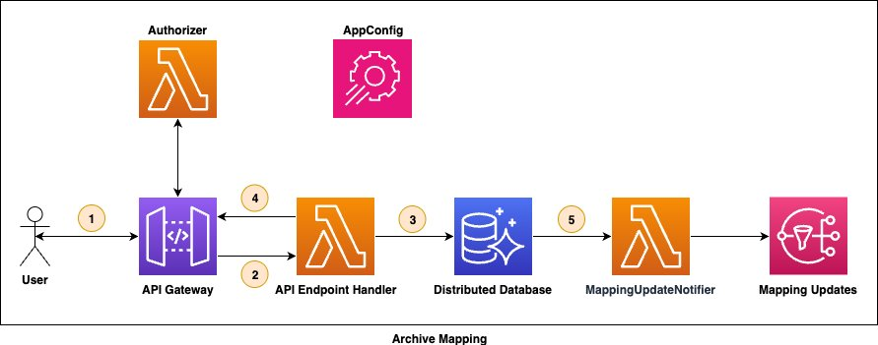
source
- Admin persona calls /mappings/{mappingId} API to archive a mapping.
- API Endpoint Handler validates the request.
- The API Endpoint Handler Updates the status in the database to ARCHIVED.
- API Endpoint Handler returns success to the API call.
- An UPDATE to the database will trigger MappingUpdateNotifier lambda. The lambda will notify downstream about the update.

APIs

Archive Mapping

HTTP Method | API Endpoint | Description
PUT | /api/v1/mappings/{mappingId}/archive | Archive a specific mapping

9.9. Mapping Feedback
Valid mappings will start appearing on public documentation, in Nexus UI, and other channels supported by downstream. Users (example: SAS consultants) can view these mappings and can submit multi-tier feedback on the mapping. They can like/dislike (thumbs up/down) and provide optional written feedback in no more than 300 words (in case of Nexus, written feedback is required to submit a feedback).

When a negative feedback is received, Nexus opens a SIM ticket with QA team to review the mapping and the feedback.
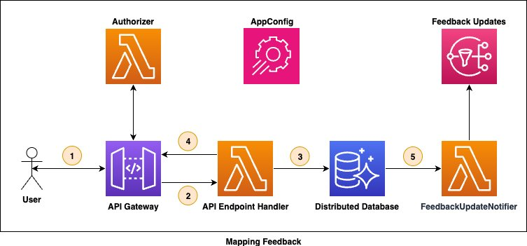

source
- Nexus receives feedbacks through a call to /feedbacks API.
- API Endpoint Handler validates the received feedback.
- The API Endpoint Handler writes the feedback to database.
- Success response is returned to the customer indicating that their feedback has been saved.
- INSERT to the database triggers FeedbackUpdateNotifier lambda. The lambda will open a SIM ticket with QA team CTI. Optionally, the lambda will send message to the Feedback Updates SNS topic, in case a notification needs to be sent to Slack channel.

APIs

Provide Feedback

HTTP Method | API Endpoint | Description
POST | /api/v1/mappings/{mappingId}/feedbacks | Save feedback for a mapping.
PUT | /api/v1/mappings/{mappingId}/feedbacks/{feedbackId} | Update a specific feedback.

List Feedbacks

HTTP Method | API Endpoint | Description
GET | /api/v1/mappings/{mappingId}/feedbacks | List all feedbacks in a paginated manner.

9.10. Search [P1 feature]
In P1, Nexus will support simple textual based search feature through the user interface. Users can search by framework name, version, controlId, control description, mappingId, etc. Search results will be returned in a paginated manner.
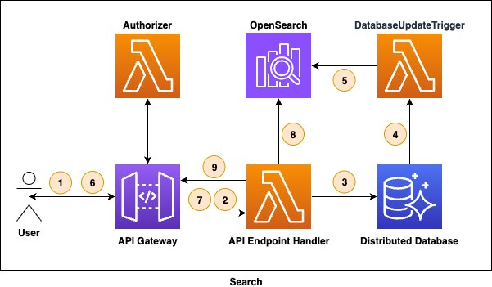

source
- User creates/updates mappings through API call.
- API Gateway forwards the request to API Endpoint Handler.
- API Endpoint handler updates the database.
- Database update triggers the DatabaseUpdateTrigger lambda.
- If the update is INSERT or UPDATE the lambda updates the content in the OpenSearch database.
- As a user starts typing words in the search bar, the UI calls the /search API and provides words written so far as in the request body.
- API Gateway forwards the request to API Endpoint Handler.
- The API Endpoint Handler uses OpenSearch to and collects search results.
- The API Endpoint Handler filters out contents with status marked as ARCHIVE .
Note: DynamoDB offers zero-ETL integration with Amazon OpenSearch service through the DynamoDB plugin: https://docs.aws.amazon.com/amazondynamodb/latest/developerguide/OpenSearchIngestionForDynamoDB.html

APIs

Search

HTTP Method | API Endpoint | Description
POST | /api/v1/search | Query text

10. Database Considerations

10.1. Base Considerations:
The following were the key BRD driven considerations for our data storage and access patterns. These are numbered for ease of referencing.
- Mappings between 2 controls are naturally bi-directional however in our base case implementation (for QA), it’s more likely we resolve an AWS control to a non-AWS control, and most lookups are uni-directional in P0 use cases.
- The mapping or control data preserved in our system ideally retains some data references to help with content enrichment or resolution when displaying for QA. This is strictly for guiding the system on what data to fetch to assist QA to accelerate their mapping. Example: Fetching docs for the control from the reference source, to do this perhaps a URL to the control source could help.
- We need a flexible schema for mapping feedback. Our P0 can be represented as a True/False label in relation to whether the system generated mapping is correct. However this off the bat may be supplemented with feedback to enter missing mappings. Note: such simple changes can drastically change the feedback storage format.
- QA feedback is many to 1 against the mapping, as we may ask for multiple rounds of QA.
- Access pattern against mappings prior to QA can be different than mapping post QA. Example:
  - Prior to QA mappings are not published to any downstream systems- thus deletes, functional edits are all possible.
  - Post QA - mappings must be stable for auditing and reference if we want to review for correctness. Our mapping may also serve as a master of record for mapping source for a downstream system.
- Mapping retrieval related logic can get complex given example use cases from BLD. Examples:
  - Get all mappings for a set of controls.
  - Get all mappings for a category or service, category or service as attributes that are on a mapping these are framework dependent.
- System may need to handle edge cases related to mapping updates (if a mapping must be removed) or control updates (if a control for some reason must be removed or edited).
- All Controls in our system will have a foreign reference, e.g. a NIST control will exist in a NIST related publication, AWS to AWS, etc.

10.2. Data and Schema Considerations
Based on the above considerations we propose to build the backbone of the storage against the control. The primary P0 use case in this system is the ingestion of a control to request a mapping. To support this our system ideally knows the full range of controls that a given control could map to. This piece of data is useful for both reference and guard-railing to avoid any mapping level hallucinations. The following schema’s do not detail all columns as this is an HLD, but attempts to provide general context for minimal data our system will need.
Due to controls being from a foreign source, we propose a simple schema for all controls (some concepts such as the system_uuid and metadata can be used for mappings too.:
 | A | B | C | D
1 | Column | Description | Reason for Need | Considerations Targeted
2 | system_uuid | Unique for a control regardless of framework source | Basic practice to have a non logical PK to drive stable indexing.  Unique for each control/mapping to help drive general Auditing and multi-key index scans. | 1, 2, 4, 5, 7
3 | foreign_reference | Some id or compound key that can help map the control to its origin source | We need to be able to audit the source of a control or mapping. Can be used to power QA enrichment. | 2, 6, 7, 8
4 | id (or title) | Logical key for mapping for control for ease of consumption  Example: framework specific control id. Examples: CT.AUTOSCALING.PR.1 rule specification or SP 800-53 Rev | Actual Logical PK | N/A
5 | metadata | One or more columns to add information to the control. This could be used as a local cache of control information to use during mapping or QA. | Place holder for flexibility | 2, 3, 4
Using the above reference control source, a mapping can be constructed by combining 2 system_uuid. This will also introduce a table which will drive most of the feature behavior of Nexus. A simple table could be constructed with:
mapping_uuid, system_uuid_1, system_uuid_2, and metadata.
When a mapping is fully published, we will likely index it into a more search empowered system to power features in the BRD for fetching mappings by control, framework, service, etc. This would handle consideration 5 from above.
The next section dives into the actual storage options and will elaborate more on consideration 5 which targets the searchability needed by the system as suggested by the BRD.

10.3. Options
We considered 3 options given above goals with them being RDBMS such as Aurora, Dynamo, S3 and combinations of them supplemented by Open Search and or ElasticCache.

10.4. Recommended: DynamoDB
We believe Dynamo addresses the general needs of our access patterns and allow the most flexible data schema adaptations given that its row is by design a flat json object. The key space for our data is a control key which is static. Control key’s are also naturally sortable presenting a nature fit against Dynamo’s indexing capabilities. Framework, Service, Category, can all serve as a partition key with sort key being the control id giving us flexibility leading into the final LLD.
Dynamo supports auto-scailing for traffic increase and secondary indexes in cases where our initial index choice is poor.
To support the search use case - we can create extra search centric tables (as new features are introduced) to mimic search queries. For example if searching for all mappings for AWS S3 to NIST we can have an index_table with key AWS:S3:NIST and store all mapping or control ids in such a row. This approach will allow us to scale search capabilities while not heavily complicating application logic. The cost will be the need to build such rows, which can be done in the duration between mapping creation and QA approval.
NOTE: all mappings can be queried by last_creation time if search indexes have not been built yet. Giving a workaround during the period of the system reaching consistency.
To avoid issues with eventual consistency picking up stale or updated data, we can conduct a final load of the control or mapping from the primary table whenever the index table is used.

Approach | Dynamo | RDS (most likely Aurora) | S3
Description | See Above | RDS offers a comparable feature set with the added ability to construct rich per table indexes, which can be achieved by flattening any metadata columns offering richer search-ability. | Team familiarity with S3 as a temp store made us consider it here. It offers similar usage patterns to Dynamo but supports much weaker indexing and searching features out of the box. This plus latency challenges made us down vote it.
Latency | Low | Low | High
Search Customizability | Medium | High | Low
Learning Curve | Low | Medium | Low
Schema Flexibility | High | Low | High
Dynamic Scalability | High | Medium | Low
Pros | Allows the most flexible data formatScales horizontallyApplication and DB logic remains light due to presence of secondary index related features. | Indexing allows for stronger search features out of the box.Joins if used right simplify query patterns in the application. | Scales the best out of all options.Flexible data format
Cons | Search support is more rigid due to lack of ability to do complex indexingJoining or raw text scanning, if needed for search, is very expensive to do. | More costly to scale and maintain. Need basic understanding of index compaction and scale up could incur minor down time.Column structure not as flexible as Dynamo unless using blob column types which limit search-ability.Requires a strong ORM or SQL knowledge for team to leverage. | No natural support to accelerate search or indexing.Slow to loadWould require the most application logic to emulate search patterns and key based queries.

10.5. Further Considerations with enhancements from Elastic Cache and Open Search
These were considered as supplemental gains on top of the existing tool set mostly for scale and search feature considerations. Per investigation we believe we do not need these today due to:
- We do not have pressing latency or throughput challenges to require elastic cache. Our system is read heavy due to QA and browsing features, however is not volume wise heavy in any form of traffic thus may not ever need the read based scale protection that caching gives.
- For search RDS and Dynamo solutions give us enough flexibility day one to need any more supplementation. Due to this we do not suggest going further into any other infra until use cases present.

11. Authentication / Authorization
Nexus is built with an API-first approach. All major functionalities are exposed as REST APIs. This will allow future systems to integrate with Nexus programmatically using APIs. Nexus also supports rich web based user interface to interact with controls and relationships. Nexus is server-less application built using AWS services, and implements default encryption of data at rest/in-transit and access control between internally interconnected subcomponents.

Nexus supports 4 roles/personas namely Service (Control Catalog), Admin, SAS Consultant, and Security Assurance QA. Personas help define a boundary on what a user can do when using Nexus. Additional details and capabilities of each persona can be found in Nexus User Stories document. Nexus implements Role-Based Access Control (RBAC) to achieve this fine-grained access control.

All authentication and authorization attempts and associated metadata are logged in CloudWatch and CloudTrail for audit and debugging purposes.

11.1. Bindle Locks
Authentication and authorization for Midway users (Web application) and application-to-application will be implemented using Bindle Locks.
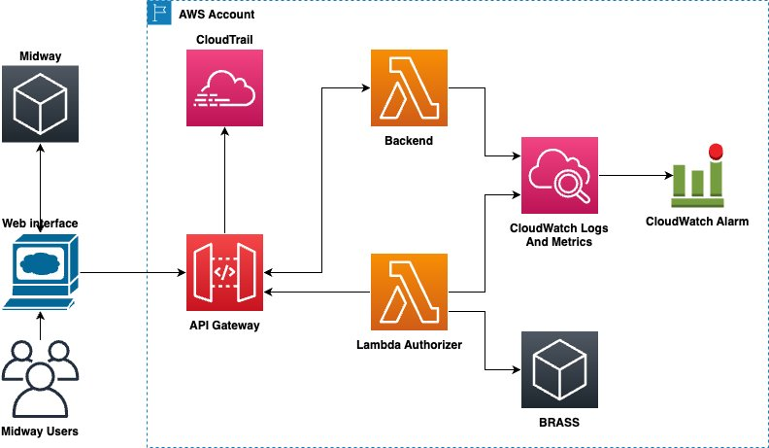
source

Use Bindle lock to control permissions.
- Create one Bindle lock for each persona.
- Grant individuals/teams and IAM Roles the permission to open a bindle lock.
  - IAM roles assumed by that applications will owned by the application team. Nexus will allow the IAM role to call APIs.
- Implement Lambda Authorizer that takes user alias (oidcSubKey) or IAM Role ARN as input and evaluates if the subject can assume the persona.
- In a descending order of priority, the lambda authorizer calls BRASS to find if the subject can acquire the bindle lock. It stops the moment it finds such a bindle and that is the persona the subject assumes.
- If a subject has permission to acquire more than one locks, they will assume the persona of the lock with highest priority. In the

11.2. WebApp AuthZ/AuthN
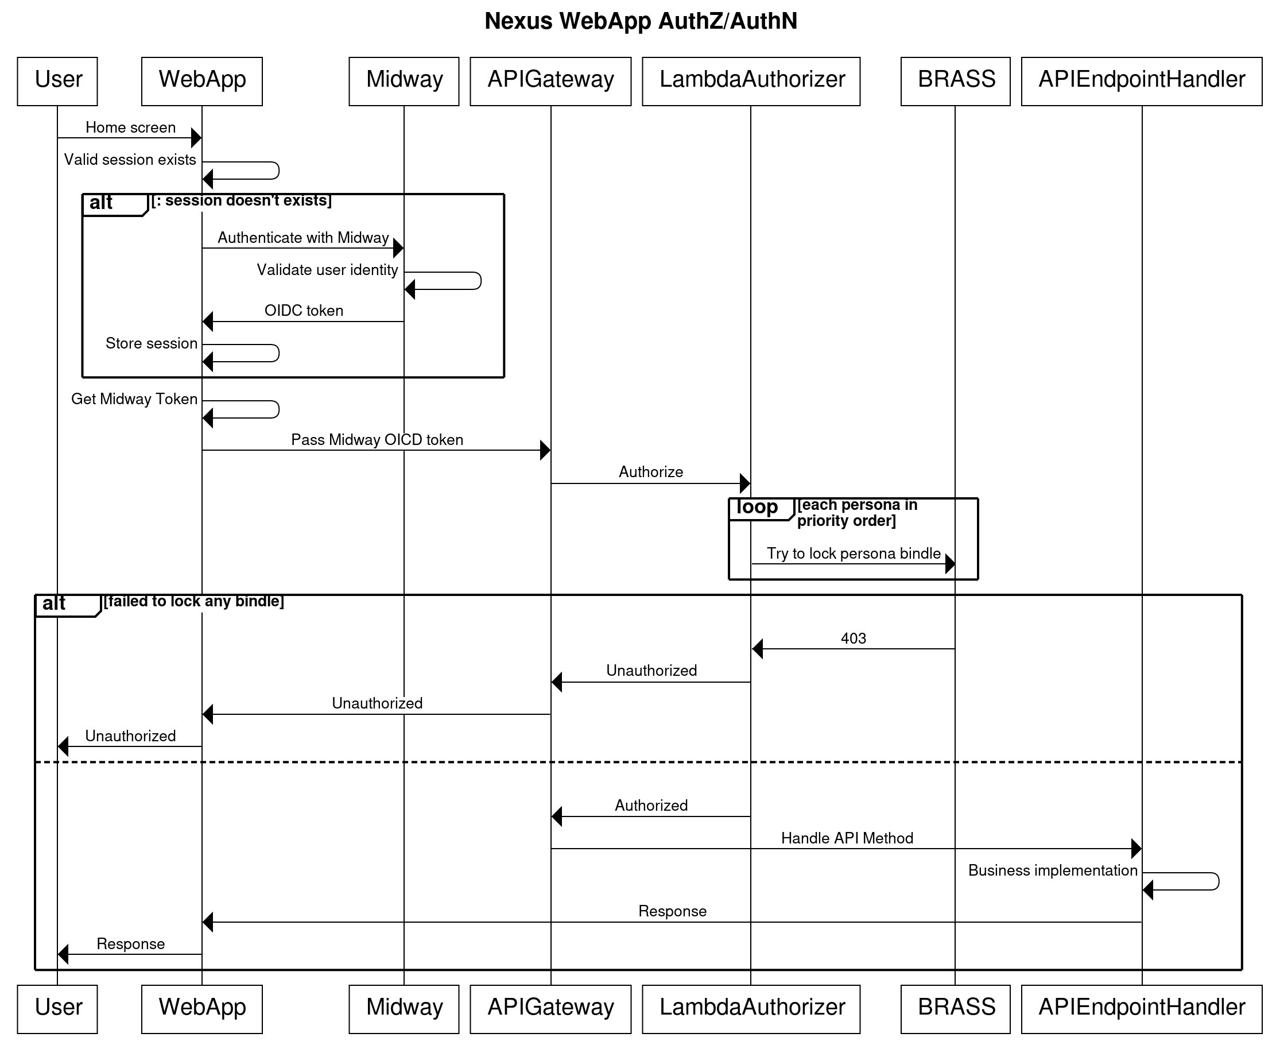
source
- User → WebApp
  - User logs in via Midway
  - Gets Midway token
- WebApp → API Gateway
  - Request with Midway token
  - No SigV4 signing needed
- API Gateway → Lambda Authorizer
  - Passes Midway token
  - Verifies token
  - Checks Bindle locks
  - Returns policy
- API Gateway evaluates policy
  - If denied: Returns 403
  - If allowed: Proceeds
- API Gateway → API Lambda
  - Includes persona context
  - Processes request
  - Returns response
- API Gateway → WebApp → User
  - Returns final response

11.3. Application-to-Application AuthZ/AuthN
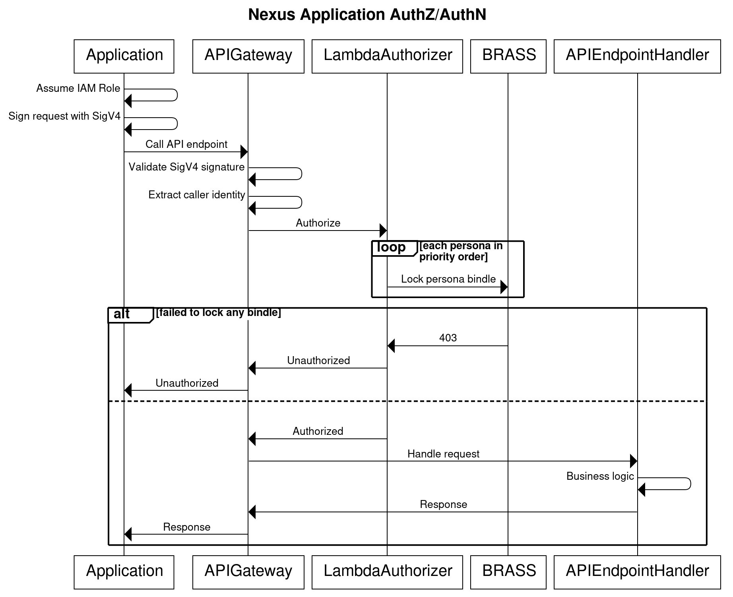
source

- Application → API Gateway
  - SigV4 signed request
  - API Gateway validates SigV4
- API Gateway → Lambda Authorizer
  - Passes caller identity
  - Authorizer checks Bindle locks
  - Returns allow/deny policy
- API Gateway evaluates policy
  - If denied: Returns 403
  - If allowed: Proceeds to step 4
- API Gateway → API Lambda
  - Includes authorizer context
  - Processes business logic
  - Returns response
- API Gateway → Client
  - Returns final response
Other authorization and authentication mechanisms were also considered. More details are available in the Appendix section Using IAM Roles and Authentication Flow with Midway - v2:. For Nexus, we will go with this implementation because of following reasons.
- Identical implementation needed in LambdaAuthorizer to support both WebApplication and Application-to-application auth.
- Access control through the use of Bindles, easy to manage.
- Calling applications control their own permissions and need to manage roles in Nexus CDK.
- Easier maintenance and better scalability

12. Science Workflow Updates
QA, SAS consultant, and crowdsourcing feedbacks are stored in databases. Optionally, feedback on controls and its enrichment can also be collected and stored (out of scope for this design doc). These feedbacks can be used to fine-tune models and create a positive feedback loop to improve inferences iteratively.

Once Nexus matures as an application, updates to science workflows may not happen frequently. Updates to science workflows will happen if better models or LLMs are available, existing ones are sunsetting, etc.

12.1. Science workflow iterations
Science workflow updates including model fine tuning will be tested in non-prod clean environment. Contents from Prod environment can be exported to the clean environment and existing mappings will act as high-confidence ground truth. Deployment ready science workflow will be used to map selected few/all controls. Resulting mappings are compared with the ground truth mapping. Few combinations can exist.
- New workflow identifies all mappings matching the ground truth: New workflow is ready to be deployed with high confidence of it working in Prod.
- New workflow misses some mappings: As ground truth mappings are human reviewed, there is a high likelihood for those mappings to be right. Either missing mappings are genuinely incorrect mappings (less likelihood), or workflow needs further tuning.
- New workflow identifies new mappings: New mappings may be genuine or false positives. Upon investigation the team concludes if the workflow needs further improvements.
- Newly identified mappings can be created using Nexus APIs in Prod. These new mappings will go through two QA review process before they can be considered as valid ones.

12.3. Science workflow versioning
A science workflow is a package of science based components like fine tuned models, specific versions of LLM, etc. all working together. A package of these components can be versioned as <<major.minor>>.
- All code associated with each component can be tagged with same <<major.minor>> version, allowing the team to retrieve artifacts from version control against a specific version.
- LLMs will be used to generate control enrichments. When these enrichments are stored in the database, LLM version along with the package version can be stored as metadata.
- Fine tuned models will be used to find mappings. Package version along with model version(s) can be stored in mapping metadata.

13. Two QA Mapping Review Process
In Figure 2: One of the AWS controls with list of available mappings to review. one can observe that one control can map to one or more other controls. Two QA review process is used to confirm if suggested mappings are valid or invalid. Following is a brief description of how this process will function.
- Through science workflows or through manual creations of mappings, a control can map to one or more other controls.
- Nexus opens a SIM with QA team as an indication that mappings for a control are ready for review. The SIM lists the source control and all its mapping pending review.
- QA team assigns the SIM to an expert referred to as QA1. Through Nexus UI, QA1 will review mappings and provide their decision on each mapping along with supporting reasoning.
- Once QA1 has provided their decision on the mapping, another expert referred to as QA2 can start reviewing the mapping.
- When QA2 reviews mappings already reviewed by QA1, they’ll see a checkbox “Final review”.
- QA2 can submit many decisions on the mapping and nexus will store all reviews in the Review database but not update the status of mapping unless QA2 checks the “Final review” and submits the decision.
- When “Final review” is checked and a decision is submitted, Nexus treats this decision as final and updates the status of the mapping.
- The simplest scenario is when QA1 and QA2 are in agreement on a mapping decision. Q2 checks the “Final review” flag and submits their decision.
- If QA1 and QA2 are in disagreement with the mapping decision, QA2 can meeting with prior QAs and come to a final conclusion. QA2 can then return to Nexus application, and submit the final decision on the mapping with “Final review” flag checked.
- If QA2 and prior QAs can’t reach a conclusive decision, they can involve a tie-breaker to reach a final decision. QA2 can then return to Nexus application and submit the final decision on the mapping.
- Submitting multiple decisions without checking “Final review” flag allows QAs to capture outcomes from intermediate steps like connecting with other QAs, or tiebreaker, etc.
“Final review” flag only appears for the last reviewer in the chain. As this is a 2 QA review, the flag will appear only after one decision has been received. This allows extending the system to N QA review process if needed. In-depth details related to the 2QA workflow can be found in QA Requirements for Nexus Mapping (P0).

14. Validation
Input validation is required to ensure Nexus stays bounded and consistent. API endpoint handlers will perform following validations.

14.1. API Payload Validation
- Data models that represents API request payload implements field validations. Failure to deserialize user requests into concrete objects returns validation error response.
- Validate if duplicate industry standards, AWS services, controls, etc. are detected and appropriate failure response is returned.

15. Throttling
Nexus implements throttling in three layers, namely WAF (Web Application Firewall), API gateway, and application. Each layer serves a different purpose in throttling.

15.1. WAF with Web ACL Layer
This is the first layer of throttling implemented using WAF (Web Application Firewall) with a Web ACL. Web ACL supports rate-based rules. These rules allow setting limit on number of requests allowed from a specific source such as IP address, within a defined time window. Following purposes are served by this layer
- IP-based rate limiting.
- Implement geographic restrictions.
- Protection against DDoS and common attack patterns.

15.2. API Gateway Layer
Global rate and burst limits on individual APIs can be implemented using API Gateway by creating usage plan. In the usage plan, rate and burst can be specified. This can be an optional safety-net layer. Following purposes are served by this layer.
- Implement global rate limits on individual APIs.
- Without this layer, all incoming requests will be handled by application. This layer protects services from getting overwhelmed and reduce service cost.

15.3. Application Layer
Application layer throttling allows fine grained access control. AWSThrottling will be used to implement application level throttling. Following purposes are served by this layer.
- Fine-grained user and API endpoint specific throttling control.
- Custom throttling related business rules.
In P0, two layers of throttling will be implemented, namely WAF with Web ACL and global rate limiting using API Gateway usage plans.

16. Monitoring and Debugging
- All application and system logs will be stored in CloudWatch.
- Authorizer logs will also be stored in CloudTrail
- All operations will emit metric.
  - Time taken to complete an operation.
  - Any errors/exceptions and their type.
  - Latency and failures for each API.
  - Latency and error/success metric for each dependency like calling Bedrock, SageMaker, Database, etc..
- Alarms will be created on critical metric.
- DLQs will have alarms to detect messages incoming to the DLQ.
- SQS queues will have alarm on number of visible messages if they exceed certain count. This will help early detect system clogs.
- Alarms on max age of messages in the SQS queue to detect microservices taking too long to process.
- Alarms on database operations to detect throttling, hot partitions, etc.
- Alarms on API responses from error family 5xx and some 4xx.
- Alarms will be placed on throttling metric.
- Dashboard to view the current state of the system. Few are some examples but not limited to just these ones.
  - Overall cost of usage.
  - Database load/health for each instance of database.
  - API endpoint handler TPS, Errors, sessions, etc
  - Most called API and top API callers.
  - API latency, availability, error rate etc.
  - End-to-end latency
  - State of canary

17. Integration and Canary Tests
Integration and canary tests can be run using the Hydra test platform. https://docs.hub.amazon.dev/hydra/.

18. Cloud Development Kit (CDK)
CDK will be used to create following artifacts.

18.1. Infrastructure
Entire Nexus infrastructure is implemented as code. Each building block in architecture diagram above is deployed as a stack.

18.2. Pipeline
Deployment pipeline will be responsible for building artifacts and deploying them in different stages. There will be 3 stages, Beta, Gamma, and Prod. These stages will be in NA region only and can be made available in other regions when needed. The pipeline will deploy all of the infrastructure like Lambdas, database, IAM permissions, AppConfig, alarms, dashboards, and many more.

The pipeline will run integration tests in each stage. Integration tests will be a blocking step and test failures will result in blocked pipeline.

18.3. Alarms and dashboard
CDK can be used to create alarms on emitted metrics. When metrics exceed alarm thresholds, tickets will be created to inform about any issues. In initial phase of development, alarms may not add much value, but without alarms, it is difficult to maintain any application.
Emitted metrics can be displayed as graphs in a dashboard. Dashboards provide a visual snapshot of health of the system and team process can be updated to periodically review dashboards to early detect a pattern.

19. A/B Testing
A/B testing will allow us to introduce new backwards incompatible changes, measure success, and switch traffic between old and new changes without code deployment and in a very controlled manner. Weblab can be used for A/B testing. Weblab is now supported in Lambda. More details can be found here https://w.amazon.com/bin/view/Weblab/Service/WeblabAllocationProvider/1_8/Lambda/.
- Code will be updated to invoke new science workflow but it will be behind a Weblab.
  - This will allow the team to either trigger both existing and the new workflow to compare how new workflow compares to the existing one.
  - Or, allow some requests to trigger the new workflow while rest of the requests will continue to trigger the existing workflow. As Weblab uses bloom filter to decide which customer gets the new workflow experience, repeated calls from same source will continue to experience the new workflow.
  - Or, simply switch to the new workflow for all traffic, perform an immediate cutover to the new workflow for all traffic, replacing the old workflow entirely..
- Weblab will allow the team to monitor health of the system over multiple days. Team can monitor QA rejection rate, model confidence rate, API error rate, E2E latency, etc.
- If the system degrades over a period of time, the Weblab can be dialed down to immediately and switch back to old workflow, else code can be permanently updated to use the new workflow.

20. Disaster Recovery
Nexus can fully recover from disasters with minimal customer impact and information loss. Nexus is build using server-less infrastructure and inherits disaster recovery capabilities out of the box. Lambda will have versioning and can be rolled back to previous version through the AWS console. Database will support point-in-time recovery to recover from data corruption.

20.1. Deployment Recovery
In case of deployment failures, successfully deployed stacks will be rolled back automatically. If application/system issues are identified after a successful deployment, Nexus pipeline can be used to rollback new changes. Deployment will be done incrementally, if issues are detected in partial deployment (alarms trigger), pipeline can be used to terminate the deployment and rollback. Post deployment the pipeline will have a cool-off period where it will monitor system stability and automatically rollback if alarms trigger.

20.2. New Feature Release
All new features will be behind a Weblab and will be slowly dialed up over couple of day span. In case of any issues, the feature can be immediately dialed down.

20.3. Database Recovery
Point-in-time recovery is enabled for DDB. This will allow restoring to a good known instance in case of a disaster. In some use-cases, multiple tables need to be updated in sequence to complete an action, there is always the risk of partial writes (few tables get updated and operation terminates). To minimize this, SQS and DLQ queues will be used to make sure that failures can be retried and update the remaining database.

21. Reference:
- Nexus User Stories: Nexus User Stories
- How to use AssumeRoleWithWebIdentity with different permissions for different users?: https://repost.aws/questions/QUORQwWvP8SXW2rXi0BuAQZA/how-to-use-assumerolewithwebidentity-with-different-permissions-for-different-users
- How to implement trusted identity propagation for applications protected by Amazon Cognito: https://aws.amazon.com/blogs/security/how-to-implement-trusted-identity-propagation-for-applications-protected-by-amazon-cognito/
- Knowledge Graph Schema for Nexus: Enhanced Control Mapping with Graph-RAG
- Nexus Dataset Sample
- Zeno BRD: https://amazon.awsapps.com/workdocs-amazon/index.html#/document/8e8d54a4545bb0d0810ab2d2cceb37f5071009f2249b2cf952d674c831ceeddf
- Nexus – Technical Implementation Plan
- CLAS Authorization & Authentication
- BRASS for Python: https://w.amazon.com/bin/view/BRASS/Onboarding#HPython
- CLAS Authentication: https://quip-amazon.com/bjQHAaols3cm
- Knowledge Graph Schema for Nexus: Knowledge Graph Schema for Nexus: Enhanced Control Mapping with Graph-RAG
- Lambda authorizer example: https://code.amazon.com/packages/CLASLambdaAuthorizer/trees/mainline
- Nexus - API Specification Document: Nexus - API Specification document
- Nexus Threat Model: Nexus Threat Model
- Nexus Control Creation and Mapping LLD: LLD - Nexus Control Creation and Mapping
- Numa Problem Statement
- QA Requirements for Nexus Mapping (P0)
- Possible Storage for Nexus
- Midway on SigV4
  - CLAS Authorization & Authentication
  - https://quip-amazon.com/bjQHAaols3cm#temp:C:LCP095b8170eff34e51b5882b0ad
  - https://quip-amazon.com/bFsAAxeJuxjA#temp:C:DXXb63998b086e24d6f943032495
- Indra Cases Authorization Design

NOTE: Please don’t read beyond this point

22. Appendix

REST API Principles
- Resources should be hierarchically organized
- Parent-child relationships should be reflected in URL structure
- The URL should read naturally from general to specific

Database Considerations
A framework is a collection of controls. Controls have enrichment information associated with them. Related controls have mappings associated with them. Mapping has QA feedback and decisions associated with them. Mapping also has crowdsourcing feedbacks associated with them. Fundamentally, data characteristics are different for each entity, intuitively a multi-table approach applies the best.

Following are some of the data access patterns worth considering when finalizing the approach.
Frameworks
- New frameworks are not added very often.
- Frameworks updates don’t occur very often.
- Frameworks are deleted only when we no longer want to support it, and that too doesn’t happen very often.
- A framework can’t be deleted if it has at least one control. Users first have to delete all controls.
Controls
- New controls are not added very often. Typically a bolus of controls are added when a new framework is added. New AWS service controls are not added at high TPS. Apart from the bolus dump, new controls are not added very often.
- Controls are not updated very often. Framework controls don’t change, and AWS controls may change, but that doesn’t happen very often. Control enrichments may change when LLM model change. When LLM model changes, updating control enrichment can be a one time offline batch operation.
- Controls are not deleted often. Controls are not really deleted from the database, their status is updated to INACTIVE.
- Control can’t be deleted if it has mappings associated with it. Users first have to delete all mappings.
Mappings
- A typical control maps to less than 10 other controls. Some outliers like PCI 2.2.1, PCI 7.2.2, PCI 7.2.5, map to 72, 55, and 54 controls respectively. There are not a lot of mappings and mappings don’t change often.
- When a mapping is identified, it goes through QA review process. Security experts review the mapping and provide their decision/opinion on the mapping. The review is stored in the database and once a mapping has been reviewed, updates are very rare. Also, review submissions are append only.
- Mapping relationships are never updated, but mapping metadata (reviews, feedback) is appended.
- Deleting a mapping is rare. Mostly happens when a mapping gets negative feedback or accidental approvals, or control deletions. Also, only Admin personas can delete mappings.
Feedbacks
- Once a mapping is published, SAS consultants and other consumers of the mapping can provide two tier feedback on the mapping. Feedbacks per control may not be too many and infrequent. Also, feedbacks are primarily append only.
- Feedbacks can’t be deleted but edits may be allowed. Frequency of edits are low.
Multi-Table updates
Consider a framework deletion. All controls within that framework must be marked INACTIVE, along with their related mappings, QA reviews, and user feedback. While Nexus employs soft deletes, this single logical operation requires updating potentially hundreds of records across multiple different tables. Without atomic transactions, a mid-operation failure creates critical data inconsistency—some records marked INACTIVE while related records remain ACTIVE, breaking referential integrity. The consequences are severe. Corrupted audit trails failing compliance audits, users accessing INACTIVE mappings referencing non-existent controls, and incomplete audit logs undermining regulatory defenses. This data fragmentation erodes system trustworthiness, exposes the organization to compliance violations, and creates scenarios where approved security control mappings point to controls that officially don't exist. This is a fundamental breach of data integrity in a security-critical application. Data integrity issues are hard to identify, harder to fix, and require prompt action. Prolonged delays may result in completely losing critical information, making it impossible to fix.

Extendible to Numa (out of scope)
Numa's Bring-Your-Own-Content (BYOC) enables customers to create custom frameworks, controls, and mappings for their unique compliance needs. While platform-wide activity may spike to high TPS, individual customer changes remain low-frequency and isolated from other tenants.

Numa provisions dedicated multi-table databases in each customer's AWS account, ensuring data sovereignty and eliminating cross-tenant interference. This architecture supports a critical hybrid model: customer-specific BYOC entities stay private in their account, while industry-standard frameworks (NIST, ISO 27001, CIS) and AWS frameworks are centrally managed and distributed to all customers. This separation delivers enterprise customization without sacrificing centralized framework maintenance, updates and expert curation benefit the entire customer base while each organization retains complete control over their proprietary compliance content.

Based on the above data access patterns, data entity relationships, and event driven architecture, we will compare two multi-table options. Both options will have following 6 tables.
Sr. No | Table Name | Purpose
1 | Frameworks | Store framework related information.
2 | Controls | Store control and related information.
3 | ControlEnrichments | Store control enrichment and related information
4 | Mapping | Store mapping information
5 | Review | Store mapping decisions and feedbacks from QA
6 | Feedback | Store crowdsourcing feedback related to mapping

9.1. DynamoDB
Multi-table strategy can be implemented using DynamoDB where each table is a DynamoDB table. With right Partition Keys, sort key, and Global Secondary Indexes, searches across tables can be very efficient. DynamoDB can scale really well with growing data needs, completely managed and has multi-region availability. Few key areas that DynamoDB lags in are:
- ACID transactions: Doesn’t support ACID transaction across multiple tables. A workaround can be implemented to contain the risk, but nothing provided out of the box. DynamoDB batch operation allows up to 100 updates/transaction.
- Expensive joins: DynamoDB doesn’t support joins across multiple tables. The burden is on the application to load all the data in-memory and perform joins. Depending on the size of dataset, it may require a system with more RAM to allow loading more data in-memory and perform joins. Also, makes it difficult to support pagination when data fetches are across multiple tables.
- Bidirectional mappings: Mappings are between two controls and is transitive in nature. If ControlA maps to ControlB, it also means that ControlB maps to ControlA. If source control is the primary key, then the mapping has to inserted twice to make the bi-directional search possible. This limitation can be overcome by creating a Global Secondary Index on the target control.
In a Single-table strategy, all tables in the DynamoDB can be collapsed to a single table. This approach directly addresses the ACID transaction limitation and the problem of bidirectional joins. Joins are greatly simplified too. But the database schema becomes too complex and requires roughly about same number of GSIs as the number of tables in a multi-table approach. If a new index needs to be added, it will be complex process to add it in a single-table approach. More about this topic can be found in this section of Appendix.

9.2. Aurora PostgreSQL
This is a relational database and inherently support multi-table data access patterns. PostgreSQL natively supports ACID transactions out of the box, joins (aggregation and filtering) and easily handled, and easy to implement bidirectional mappings. Few key areas where Aura PostgreSQL lags are:
- Learning curve: Dynamo is widely used within Amazon with expertise easily available.
- Storage limit: Unlike DynamoDB that supports Petabyte+ storage, PostgreSQL has a limit of 128 Tebibyte (TiB. This is 10% larger than TB). Though this limit is about 6000x more than what Nexus and Numa may need, but if the data ever exceeds this limit, database decision will need a revisit. Aurora PostgreSQL Limitless provides Petabyte+ storage with sharding support and migration from classic PostgreSQL to Limitless is about 2 months.
- Cost: With increase in database size, the cost of system to host large database increases.

9.3. Other Databases

9.3.1. Neptune DB
We looked at NeptuneDB because of the hierarchical relationship between frameworks, controls, mappings, feedbacks, etc. Few of the primary reasons why we decided not to use Neptune database are following.
- Tabular data model: Once mappings are identified, mapping access is tabular in nature than graphical.
- Multi-node updates: Multi-node updates in Neptune are complex to implement.
- Query complexity: Even simple access operations require comparatively complex queries.
- Cost: Neptune is about 5x expensive than DynamoDB.

9.3.2. Redis
Redis is an open-source, in-memory data store and message broker known for high throughput and low latency. While Redis uses key-value structures rather than tables, similar data modeling patterns could apply as with multi-table DynamoDB. Redis delivers faster in-memory operations than DynamoDB but incurs higher infrastructure costs. DynamoDB and PostgreSQL provide sufficient performance for Nexus requirements. As an in-memory store, Redis requires persistence management through built-in mechanisms (RDB snapshots, AOF logs) or a separate backing store. When used as a cache, updates must be synchronized with persistent storage, introducing complexity for consistency and durability. These operational overheads and higher costs make Redis overkill for this application, where DynamoDB or PostgreSQL adequately meet performance needs.

9.4. Conclusion
Note: The final choice will be made in a LLD where a thorough comparison will be conducted based on database schemas, that will influence number of entity tables, and many other criteria. Please consider rest of the content non-conclusive and just as inputs to LLD.

Following is the table to compare DynamoDB multi-table approach vs Aurora PostgreSQL approach. Each comparison criteria is given a score between 1 to 10, where 1 being the worse while 10 being the best case. Each criteria are weighted (sum of all weights should be 100), score of each criteria is multiplied by the weight and added together. As both database approaches will work, this table may act as a model to statistically identify the right database. Higher weighted sum is better. To limit the scope of this document, assumption is that both database have the most optimal schema.
Criteria |  | DynmoDB Multi-table |  |  | Aurora PostgreSQL
Description | Weight | Description | Score | Weighted | Description | Score | Weighted
ACID Transactions | 2 | No cross-table ACID, requires multiple transactions with rollback complexity | 3 | 6 | Full ACID across all shards. | 8 | 16
Data Consistency | 20 | Application-enforced. Bug in update logic → orphaned mappings, inconsistent data. Hard to detect and fix | 5 | 100 | Database-enforced foreign keys + ACID. Inconsistency impossible | 8 | 160
Schema Complexity | 5 | 6 tables with complex partition key design (PK/SK patterns). No enforced relationships | 6 | 30 | Natural relational schema with foreign keys. Enforced referential integrity. | 7 | 35
Extensibility | 15 | New query patterns require GSI creation or table restructuring. | 4 | 60 | New queries = new SQL. Add indexes as needed. Stored procedures for business logic. | 6 | 90
Triggers | 5 | DynamoDB Streams + Lambda | 8 | 40 | Native triggers. Single-shard triggers: 10-50ms. Cross-shard: 100-500ms. | 10 | 50
Cost (30K queries/mo) | 4 | ~ $104/mo On-Demand | 10 | 40 | ~ $187/mo single-shard | 8 | 32
Storage Limit | 2 | Petabyte+ | 10 | 20 | 128 TiB | 6 | 12
Read throughput (100 items, 4KB each) | 5 | 3,000 RCU/sec/shard, ~ 30 queries/sec | 6 | 30 | ~75,000 queries/sec/shard | 8 | 40
Write throughput (100 items, 1KB each) | 2 | 1,000 WCU/sec/shard, ~ 10 queries/sec | 6 | 12 | ~30,000 writes/sec/shard | 8 | 16
Application Complexity | 10 | High: 200-300 LOC for complex queries. Manual joins, batching, retry logic, partial failure handling | 5 | 50 | Low: 20-30 LOC using SQL. Database handles joins, aggregation, consistency | 8 | 80
Learning Curve | 5 | Familiar database | 8 | 40 | Steep learning curve | 5 | 25
Development velocity | 5 | Fast delivery | 8 | 40 | Slow start due to learning time | 6 | 30
Long-term maintainability | 10 | Complex application logic | 5 | 50 | Timely query/stored procedure optimizations needed | 8 | 80
Maintenance | 10 | Monitor hot partitions, manage GSIs, capacity planning | 6 | 60 | Standard database maintenance. | 7 | 70
Total | 100 |  |  | 578 |  |  | 736

Key-Value Based vs Relational Database

Assumptions

Framework
- Framework is a collection of controls. A control must associate with an framework. There are some industry frameworks (targeting 17 by end of the year) and all of the AWS controls can either be put under a virtual fictitious AWS_Framework or each AWS service can be a framework, example: All S3 controls can be part of AWS_S3_Framework, while all EC2 controls can be part of AWS_EC2_Framework, etc. In case of Numa, customers can create one or more frameworks to group their BYOCs. Once service is launched to AWS customers, there can be potentially millions of frameworks and billions of controls.
- A framework may have some basic metadata associated with them, such as name, id, description, source, version, etc. This metadata needs to be stored in the database.
- A framework can be deleted either by Numa customers, or when AWS decides to no longer support an outdated industry framework, etc. Database should support CRUD operations.

Control
- A control can have metadata associated with it, such as control_id, description, title, enriched content, etc.
- An interpretation of a control can change over time, an update to an existing control will result in creating a new version of the same control.
- A control can be deleted. AWS may delete old controls, or Numa users can delete their BYOCs. Database should support CRUD operations for controls.
- Total control counts can potentially exceed billions in count. There are about 2 million AWS customers and if they all bring 100 BYOC, the control count is 2 billion.
- Updates to controls will be more frequent than updates to frameworks.

Mappings
- A mapping is between two controls. Mapping is bidirectional, if ControlA maps to ControlB, ControlB also maps to ControlA.
- A user may ask questions such as, given a AWS control, list all framework controls it maps to. Similarly, given a framework control, list all AWC controls it maps to.
- A mapping goes through approval process. Review feedbacks and decisions are stored with mapping.
- Metadata associated with a mapping are control_Id_A, control_id_B, mapping_status, reviewer feedbacks, SAS_consultant_feedback.
- Mapping can be deleted. The database should support creation and deletion of mappings.

Database Comparisons

Key-Value Based

Multi-Table DynamoDB
- Frameworks: Create a table for frameworks that stores framework metadata
- Controls: Create a table for controls, stores information like frameworkId, controlId, control details, etc.
- Mappings: Create a table for mappings. As mappings are bi-directional, either insert each mapping twice with controls switched, or create a global secondary index on the second control column.
- Feedback: Create a table to gathering decision and feedback on each mapping.
- Enrichment: Enriched control data

Single-Table DynamoDB
One of the potential issues with Multi-Table approach is that ACID operations are not guaranteed and takes multiple steps. As an example, when a control is deleted, first get the list of all mappings it has, then delete contents related to mappings from the feedback table. Once successful, delete mappings from mapping tables, and then delete the control. If any of these operations fail, tables will end up in an unrecoverable state. As an example, if mapping feedback is deleted but failure occurs when deleting the mapping will leave the system in an inconsistent state. More robust architectures can be used to minimize this risk, but the risk always remains.

Another drawback of using single table approach is that the burden of join is on the application. Application calls multiple tables and then performs joins to obtain desired information. As an example, to view a control and it’s mappings, the application has to query controls table to get control information, then call the mapping table to obtain mappings, then again call controls table to get details of each control in the list of mappings, then call the feedback table to get feedback information for each mapping.

Single-Table DynamoDB approach addresses some of these problems by storing everything in a single table. This makes write operations ACID and minimizes application complexity as all needed information in available in a single table.
- Use CONTROL/FRAMEWORK prefix before the corresponding ID and use it as Partition Key. Example, CONTROL#NIST-AS-1, FRAMEWORK#NIST-800-53. # is just a delimiter and can be anything else.
- Create a Sort key on hierarchical structure. As an example, Framework will have metadata, Control can have metadata, enrichment, mapping, and review.
  - METADATA
  - ENRICHMENT
  - MAPPING#<other-control-id>
  - MAPPING#<control>#REVIEW#<review-id>#<timestamp>
- Create one Global Secondary Index GSI1PK with sort key GSI1SK. This is required to allow bi-directional mapping query. GSI1PK is on the other control in the mapping.
- Create another GSI2PK with sort key GSI2SK. where GSI2PK is on the hierarchical attributes. This allows more complex queries such as listed in table below.
 | Query Pattern | GSI2PK Value | GSI2SK Value | Use Case
1 | Framework queries | FRAMEWORK#NIST-800-53 | CONTROL#NIST-AC-1 | List all controls in a framework
2 | Category queries | CATEGORY#Access Control | CONTROL#NIST-AC-1 | List all controls in a category
3 | Framework mappings | FWMAP#ISO-27001#NIST-800-53 | 2024-01-15T10:00:00Z | List all mappings between two frameworks
4 | All frameworks | ALLFRAMEWORKS | FRAMEWORK#NIST-800-53 | List all available frameworks

Conclusion
The single table approach addresses some of the limitations of multi-table approach, but a multi-table approach is preferred because it is comparatively simple to implement, maintain, and is extensible. Single table approach has a complex schema and adding more features in future will require Database schema changes.

Relational Database
Framework is a collection of controls, controls in different framework have mappings between them, mappings have feedbacks associated with them, etc. This organization of data is relational in nature and a relational database may be a natural fit. A relational database can have multiple tables as suggested in the DynamoDB based multi-table approach.

Primary advantages relational databases have over column based approach are following.
- Supports ACID, making updating multiple tables reliable. All tables get updated or updates are rolledback in case of errors.
- Easy to extend as based on new use-cases, new tables can be easily added.
- Adding new columns to existing table is easy, allowing to store more attributes.
- Complexities related to joining information from multiple tables is abstracted from the application. The application gets the final result of their queries.
- Complex workflows can be easily created, as an example, an INSERT operation in the control table can automatically trigger the mapping workflow without requiring an application to orchestrate the flow. Similarly, an INSERT in the feedback table can automatically trigger a workflow to mark a mapping valid (once sufficient feedbacks have been received) and notify downstream.

Conclusion
For storing framework controls and mappings, multi-table DynamoDB lacks ACID guarantees across tables and requires application-side joins, creating consistency risks. Single-table DynamoDB improves transactional consistency and reduces application complexity but demands sophisticated upfront schema design. Relational databases are the best fit, offering full ACID support, native JOIN operations, straightforward extensibility, and built-in workflow triggers. Given the relational nature of frameworks, controls, and bidirectional mappings with feedback, a relational database provides the simplest implementation and maintenance path while supporting complex queries and ensuring data consistency.
 | Criteria | Multi-Table DynamoDB | Single-Table DynamoDB | Relational Database
1 | ACID Transactions | Low | Medium | High
2 | Schema Complexity | Low | High | Low
3 | Application Join Logic | High (App-side joins) | Low (Single table) | Low (Native JOINs)
4 | Extensibility | Medium | Medium | High
5 | Query Flexibility | Low | Medium | High
6 | Bidirectional Mapping | Medium (GSI needed) | Medium (GSI needed) | High (Native support)
7 | Data Consistency Risk | High | Low | Low
8 | Implementation Complexity | Low | High | Low
9 | Maintenance Burden | High | High | Low
10 | Fit for Use Case | Low | Medium | High

Single Table DynamoDB structure
Primary Keys (Required for all items)
PK (Partition Key): Primary identifier following pattern ENTITY#ID
Controls: CONTROL#NIST-AC-1
Frameworks: FRAMEWORK#NIST-800-53
SK (Sort Key): Hierarchical structure enabling item type differentiation
Metadata: METADATA
Enrichment: ENRICHMENT
Mappings: MAPPING#<other-control-id>
Reviews: MAPPING#<control>#REVIEW#<reviewer-id>#<timestamp>
GSI Attributes
GSI1PK / GSI1SK: Reverse mapping lookups (bidirectional queries)
GSI2PK / GSI2SK: Multi-purpose index
Framework queries: FRAMEWORK#NIST-800-53
Category queries: CATEGORY#Access Control
Framework-to-framework mappings: FWMAP#ISO-27001#NIST-800-53
All frameworks list: ALLFRAMEWORKS
entity_type: Used as GSI3PK for querying by type (CONTROL, MAPPING, REVIEW, ENRICHMENT, FRAMEWORK)
reviewer_id: Used as GSI4PK for reviewer-specific queries
created_at / review_date: Used as range keys for time-based sorting
Control Attributes
control_id: Unique identifier (e.g., "NIST-AC-1")
control_text: Full control description
source_framework: Framework name (e.g., "NIST-800-53")
version: Framework version
status: ACTIVE, DEPRECATED, DRAFT
control_family: Control family code
priority: HIGH, MEDIUM, LOW
updated_at: Last modification timestamp
Enrichment Attributes
category: Primary category (e.g., "Access Control")
subcategory: Detailed classification
keywords: Array of extracted keywords
risk_level: HIGH, MEDIUM, LOW
extracted_entities: NLP-extracted entities
enrichment_status: COMPLETED, PENDING, FAILED
enriched_at: Processing timestamp
enrichment_version: Version of enrichment algorithm
Mapping Attributes
control_1 / control_2: The two controls being mapped (alphabetically ordered)
framework_1 / framework_2: Source frameworks
mapping_type: EQUIVALENT, RELATED, SUBSET, SUPERSET
confidence_score: 0.0 to 1.0 decimal
mapping_method: ML_SIMILARITY, MANUAL, KEYWORD_MATCH
Approval Workflow Attributes
approval_status: PENDING_REVIEW, UNDER_REVIEW, APPROVED, REJECTED
required_approvals: Number of approvals needed (default: 3)
current_approvals: Current approval count
current_rejections: Current rejection count
approval_threshold: Percentage threshold (e.g., 0.67)
submitted_by: User who created mapping
submitted_at: Submission timestamp
approved_at: Final approval timestamp (null if pending)
approved_by: Final approver ID
Review Attributes
review_id: Unique review identifier
mapping_control_1 / mapping_control_2: References to mapped controls
reviewer_id: Unique reviewer identifier
reviewer_name: Full name
reviewer_email: Contact email
reviewer_role: COMPLIANCE_OFFICER, SECURITY_EXPERT, AUDITOR
vote: APPROVED, REJECTED, NEEDS_REVISION
feedback: Text feedback/comments
confidence_assessment: HIGH, MEDIUM, LOW (reviewers confidence)
suggested_mapping_type: Alternative mapping type if disagreeing
review_round: Revision round number (1, 2, 3...)
time_spent_minutes: Time spent reviewing
Framework Attributes
framework_id: Unique identifier
framework_name: Full name
description: Framework description
publisher: Issuing organization
published_date: Release date
total_controls: Count of controls
Universal Attributes
entity_type: CONTROL, MAPPING, REVIEW, ENRICHMENT, FRAMEWORK
created_at: Creation timestamp (ISO 8601)
updated_at: Last update timestamp

Control mapping schema
{
"mapping-collection": {
"uuid": "2e1ba8df-3780-4550-a332-8cf63c605510",
"metadata": {
"title": "Minimal OSCAL Mapping Collection",
"last-modified": "2025-05-19T12:56:00Z",
"version": "1.0.0",
"oscal-version": "1.2.0"
},
"provenance": {
"method": "human",
"matching-rationale": "semantic",
"status": "draft",
"confidence-score": "high",
"mapping-description": "A minimal mapping between control frameworks"
},
"mappings": [
{
"uuid": "ec82f0b3-27a5-490f-9c35-5a2b99a34919",
"source-resource": {
"type": "catalog",
"href": "https://example.org/source-catalog.json"
},
"target-resource": {
"type": "catalog",
"href": "https://example.org/target-catalog.json"
},
"maps": [
{
"uuid": "45da895d-9982-4a64-9036-bdc8240475c5",
"relationship": "equivalent",
"sources": [
{
"type": "control",
"id-ref": "source-control-1"
}
],
"targets": [
{
"type": "control",
"id-ref": "target-control-1"
}
]
}
]
}
]
}
}

Different options considered for AI based asynchronous workflows

6.1.1 Step Function [Preferred]
source
- User calls Ingestion API and provides list of URLs of documents to ingest.
- API endpoint handler generates a referenceId, adds an entry in the Data Ingestion Status DDB, starts the step function, and returns the referenceId to client in the 202 response.
- The event used to trigger the step function will have API request payload, clientId, sessionId, configIdentifier, and referenceId.
- In the step function, lambda will upload documents to Nexus S3 bucket and move to the next step. If a folder for clientId + sessionId doesn’t exist in S3, the lambda will first create one before uploading documents to it.
- If a Neptune DB instance doesn’t exist for clientId + sessionId , the lambda will create a new instance of Neptune DB before proceeding further.
- ESC Fargate cluster will start ingesting files from clientId + sessionId S3 bucket, obtain ingestion configuration associated with configIdentifier from AppConfig, and based on that put the document in Neptune DB.
- ECS Fargate will have retries for recoverable failures. If operation fails after retries, the ingestion request will be put into a SQS queue. Ideally no message should be in the SQS queue.
- If a message arrives in the retry SQS queue, it will trigger an alarm to get team’s attention to investigation and determine the reason for failure. The request can be retried by driving messages to the retry lambda. Retry lambda is needed because messages in SQS cannot start a step-function.

6.1.2 AWS Glue
AWS Glue job can be used to ingest documents. Document ingestion option is not available out of the box in AWS Glue but a mechanism can be put together to achieve this.
- The Ingestion API handler lambda will create a SQS message with details like request payload, session info, referenceId, etc. and put it into the SQS queue.
- As AWS Glue jobs cannot be triggered by SQS directly, we will need a lambda to call AWS Glue job. This Lambda will be triggered by messages in the SQS.
- The lambda will pass information from SQS message and pipeline configuration from AppConfig as Glue job parameter.
- Python code to ingest documents, will be put at a S3 location and AWS Glue job will be configured to use this python script .
- The python script depends on 3rd party libraries not supported by AWS Glue. These 3rd party libraries needs to be packaged into a wheel file and uploaded to S3 location. Path to wheel files will be provided as CSV for Python library path config in Glue job. Steps to create wheel file can be found here: https://leondesilva.medium.com/step-by-step-guide-for-writing-a-simple-aws-glue-job-in-python-944d64a5c849
- Glue 5.0 has a max job timeout of 480 minutes, which is 8 hours. This should be sufficient time to ingest a document.
- Need to figure out monitoring and alarm to detect failures.
CDK code reference to configure AWS Glue can be found here.

6.1.3 ECS with EC2 instances
Instead of using Step-Function, ECS fleet can be used to lift the entire heavy weight of document ingestion. Depending on the load, more instances can be started and instances will be torn down once load goes down. At least one instance will always be running even when there is no document to ingest.

6.1.4 Conclusion

 | A | B | C | D | E | F
1 | Sr. No | Notes | StepFunction | Glue | EC2
2 | 1 | Implementation complexity | Medium | High | Low
3 | 2 | Operational overhead | Low | Low | High
4 | 3 | Cost | Low | Low | High
5 | 4 | Scaling and descaling | HIgh | Low | Medium
Based on the table above, StepFunction stands out as the preferred approach.

Different Neptune DB modes considered

6.1.5 Neptune database
Documents can be ingested in Neptune database using different strategies. A new instance of database can be created for each use-case, or in a single database as multi-tenants, or in a hybrid manner. Each option is discussed below.

6.1.5.1 Neptune - Silo Model
In this model a new cluster is created for each customer use-case and all documents related to the use-case are ingested into this fully separated cluster. This provides flexibility of using different embedding models for each use-case and also any issues related to noisy neighbors or compliance and regulations. Access to the resource can be controlled using user’s IAM permissions if needed.
In this model, each cluster has its own individual endpoint and as a result, a single user can have multiple instances, one for each use-case. Nexus will need to manage endpoint and use-case mapping in a database and the lifecycle of these instances. Once user is done with their use-case, a mechanism will be needed to delete associated database instance and free resources.
Assuming the average document set to be medium size, each Neptune instance can be deployed on db.r5.largeinstance. This instance type costs $0.348/minute. Assuming each instance to exist for 7 days, and if there are K use-cases, the cost of launching K instances for 1 week will be roughly around 0.348 x 60 (mins) x 24 (hours) x 7 (days) x K (instances) = K x 3507.

6.1.5.2 Neptune - Multi-tenant Model
This model requires a single instance of Neptune cluster and data from all use-cases can be placed as tenants. Tenants can be modeled as node partitions to avoid crossing over of any data from other tenants. All data related operations such as data ingestion, retrieval, etc will be performed on the partitionId. As there is only one instance of the database, only a single embedding model can be used for all tenants and this could be limiting.
As there is just a single endpoint and the database instance is never torn down (only partitions are created/deleted), this model does not have an overhead of managing database endpoints and lifecycle. If the user forgets to clean their partition, this will increase the size of the database with time. Implementation for data ingestion, retrieval and other database operations will be more complex.
As all tenants live in the same database instance, it will require a high tear instance of database. Assuming the database is deployed on db.r5d.xlarge instance, it costs $0.7954/minute. This model will cost about 0.7954 x 60 (mins) x 24 (hours) x 7 (days) = $8,017/week. The cost of running this model is not directly proportional to number of tenants.

6.1.5.3 Neptune - Hybrid Model
Hybrid model is the best of both worlds. Data from each use-case requiring a different embedding model will reside in a different instance of the database. Data for use-cases requiring same embedding model can co-exist in the same database as tenants.
Complexity to implement this model is higher than other models.

6.1.5.4 Conclusion

 | A | B | C | D | E
1 | Sr. No | Notes | Silo Model | Multi-tenant Model | Hybrid Model
2 | 1 | Support for different embedding models | Yes | No | Yes
3 | 2 | Operational overhead | High | Low | Medium
4 | 3 | Cost of infrastructure | High | Low | Medium
5 | 4 | Implementation complexity | Low | Medium | High
Based on the table above, multi-tenant model can’t be used because it does not offer the flexibility of using different embedding models. Hybrid model is optimal, but comes at a high implementation complexity cost. It is recommended to start with Silo Model and maybe in future switch to hybrid model.

Personas
Nexus supports 6 key personas, namely SAS Consultant, Control Governance, Audit Manager, Compass QA, Security Assurance QA, and Zeno Business owner. These personas represent different user roles interacting with Nexus for compliance mapping automation. Following is a summary of responsibilities of each persona, more details related to personas can be found in BRD_Zero_2025 doc.

SAS Consultant:
  - Review and filter AWS services and industry frameworks
  - Select and identify common controls and their mapped AWS managed security rules
  - Review framework controls not mapped to AWS managed rules
  - Provide customers with applicable AWS service API calls for control verification
  - Review and validate automated mappings

Controls Governance (Config, Control Tower, and Security Hub):
  - Request new AWS managed rules to be mapped to industry framework controls
  - Review domain, objective, and common control mappings for new rules

Audit Manager:
  - Export and manage control mapping datasets
  - Request new industry framework mappings against AWS managed rules
  - Request new framework mappings against AWS APIs for evidence collection
  - Request new framework mappings against AWS CloudTrail Events

Compass QA:
  - Receive and review new mapping notifications
  - Approve/reject mappings with comments
  - Review technical details like Control Guide descriptions, API calls, and framework mappings

Security Assurance QA:
  - Review mapping decisions made by Compass QA
  - Approve/reject mapping decisions with comments
  - Provide final validation of mappings

Zeno Business Owner:
  - Monitor service performance metrics and KPIs
  - Manage framework versions and updates
  - Review QA metrics and trends
  - Monitor service costs and ROI
  - Track usage metrics and user access
  - Manage framework addition/removal and metadata
  - Monitor service health and availability

AuthZ/AuthN Using IAM Roles
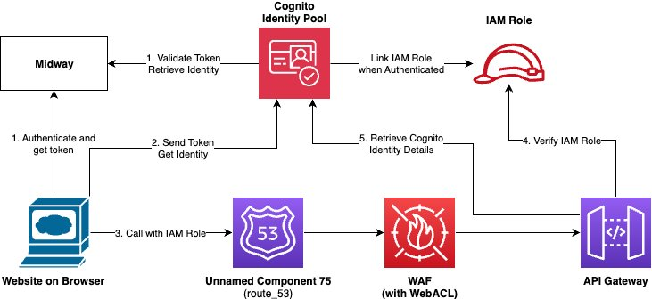

source

Authentication
Nexus will be available to Amazon employees who can acquire a valid Midway token and can assume IAM Role to call Nexus API endpoint. For authentication, Nexus requires Midway MFA with Amazon Cognito and AWS IAM role principal when accessed though the web interface and AWS IAM role principal Sigv4 when Nexus REST API endpoint is called directly.

For Web UI Access:
- Midway (Amazon's internal SSO) for employee authentication
- JWT token management for session handling
- Integration with internal Amazon authentication services

For REST API Access:
- Amazon internal service authentication (Isengard/Ping)
- IAM role-based authentication
- API keys for service-to-service calls within AWS

Authorization
API Gateway implements authorization through IAM Policies, IAM roles, and AWS account. Fine-grained access control is managed through IAM policies attached to roles, with specific permission sets defined for each service function. Service also manages resource access control using internally stored states in Dynamo DB. As an example, documents provided principal-A cannot be accessed, updated, and deleted by principal-B.

IAM role and policies are used for authorization between different subsystems within the services like DynamoDB, Neptune DB, Lambda, CloudWatch, etc. Data exchange between these internal subsystems is encrypted in transit using TLS. Subsystems within the service are not accessible to external principals.

Authentication Flow with Midway and IAM roles:

Web-based UI Access:

Authentication:
- User accesses Nexus web interface.
- Redirected to Midway for authentication.
- User authenticates with their Amazon credentials.
- Midway provides authentication token.
- Token contains user identity and group memberships.
Authorization:
- Midway token is exchanged for AWS temporary credentials via AWS STS.
- User is mapped to appropriate IAM role based on their persona.
- IAM role determines accessible features and resources.
- Session maintains both Midway context and AWS credentials.

REST API Access:
- For Internal Amazon Users (via Midway):
  - Client obtains Midway token
  - Token exchanged for temporary AWS credentials
  - API calls include these credentials
  - API Gateway validates AWS credentials
  - Permissions enforced based on assumed IAM role
- For Application-to-Application calls:
  - Calling application uses IAM roles
  - No Midway authentication required
  - API Gateway validates IAM credentials
  - Authorization based on IAM role permissions

For testing purposes, using tools such as curl to access REST APIs.
- Obtain midway token:
  - Open browser and navigate to Midway console.
  - Authenticate with your Amazon credentials.
  - Copy the Midway token.
- Exchange Midway token for AWS credentials:
curl -X POST \
https://sts.amazonaws.com/ \
--data-urlencode "Action=AssumeRoleWithWebIdentity" \
--data-urlencode "Version=2011-06-15" \
--data-urlencode "RoleArn=arn:aws:iam::ACCOUNT_ID:role/ROLE_NAME" \
--data-urlencode "RoleSessionName=NexusSession" \
--data-urlencode "WebIdentityToken=MIDWAY_TOKEN"
- Make API call using temporary credentials:
curl -X GET \
'https://your-api-endpoint.amazonaws.com/path' \
-H 'Authorization: AWS4-HMAC-SHA256 Credential=${ACCESS_KEY_ID}/date/region/execute-api/aws4_request' \
-H 'X-Amz-Security-Token: ${SESSION_TOKEN}' \
-H 'X-Amz-Date: ${TIMESTAMP}'

Persona Management:
- Six IAM Roles (One per persona).
- Each role has specific permission policies.
- Roles control resource access levels.
- Cross-account access configured if needed.

IAM Role Structure:
- Create six IAM roles (one per persona):
  - NexusAdminRole
  - NexusOperatorRole
  - NexusDeveloperRole
  - NexusAnalystRole
  - NexusAuditorRole
  - NexusBasicUserRole
- API Access Control:
  - API Gateway Configuration:
    - Enable IAM authorization
    - Allow all six roles to invoke APIs
    - Pass role context to backend
  - Backend Processing:
    - Validate IAM role of caller
    - Filter response data based on role
    - Apply role-specific business logic
    - Return appropriate response content
- Web UI Access Control:
  - Frontend Authentication:
    - Allow access with any of six roles
    - Capture assumed role information
    - Maintain role context in session
  - UI Component Control:
    - Show/hide features based on role
    - Disable unauthorized actions
    - Filter displayed data
    - Customize navigation options

IAM Policy Structure
- Base Policy (attached to all roles):
- Allow API Gateway invocation
- Allow Web UI access
- Allow basic read operations
- Allow session management
- Role-Specific Policies:
Admin Role:
- Full access to all features
- Complete data visibility
- Management capabilities
Operator Role:
- Operational access
- Limited management features
- Filtered sensitive data
Developer Role:
- Development environment access
- Test data visibility
- Limited production access
[Similar policies for other roles]

AuthZ/AuthN Authentication Flow with Midway - v2:
Web UI Access:
- When an Amazon employee accesses Nexus web UI, they are redirected to Midway
- Employee authenticates using their corporate credentials through Midway.
- Midway issues a SAML assertion containing the employee's identity and group memberships
- Token Exchange:
  - The SAML assertion from Midway is exchanged for temporary AWS credentials using AWS STS.
  - These temporary credentials are used to access AWS services.
- Amazon Cognito user pool is configured to trust Midway as the identity provider
- Authorization Flow:
  - The application receives the user context including:
    - Employee identifier
    - Group memberships
    - Assigned personas
  - API Gateway custom authorizer validates the Midway token
  - Permissions are evaluated based on the user's persona
For REST API Access:
- Requests include Midway token
- Custom authorizer validates the token
- Authorization decisions are based on user's persona
Service-to-Service Calls:
- Internal services use IAM roles and AWS STS
- Services assume appropriate roles with temporary credentials
- API Gateway validates IAM credentials

AuthZ/AuthN using Helis
Helis - Policy Management System

